Communications – Product Strategy & Execution Plan (2026–2028) 2
1. Executive Summary 2
2. Background & Introduction 3
3. Main Pain Points & Opportunity 3
4. Use Cases & Jobs To Be Done 7
5. Market & Competitor Analysis 10
6. Communication Types & Channel Framework 12
7. Foundational Principles 14
8. CDP Requirements for CEP Orchestration (ROW + CH) 15
9. Product Strategy & Approach 18
10. Cost & Investment Envelope (2026–2027) 19
11. Execution Plan (Pillar-by-Pillar) 23

Communications – Product Strategy & Execution Plan (2026–2028)

1. Executive Summary

Why now (and what differentiates this program)
Aurora now provides event infrastructure, UI flexibility to insert channels, and multiapplication readiness; with Braze (CEP) and Segment (CDP/aggregator) in place, the organization can centralize decisioning and delivery at speed. Acting this year is time critical to remain competitive and to support company OKRs—particularly Grow Upmarket (adoption & usage) and Brilliant at the Basics (retention, CX, cost discipline)—by enabling scalable, governed, multichannel communication across My Account, Manager Account, and Partner Admin. As the platform evolves toward multi-role and multi-entity, communication becomes imperative: infrastructure must support delivering role and entity appropriate guidance to the right users, and meeting customers in the right application where work happens (e.g., Manager Account). Delay increases cost, compounds fragmentation, and slows growth motion. Communication is not a messaging function — it is platform infrastructure. Without it, multi-role, multi-entity, multi-application operation cannot scale or meet regulatory and CX expectations.

What this strategy does
Builds a centralized, event driven orchestration layer with multivendor support (Braze for ROW and BessChannel for China by design), governed through standards, reusable templates, and policy-as-code; instruments internal and external channels end-to-end; and provides BackOffice traceability for auditability and explainability. Centralization is the prerequisite for (1) a Preference Center that can reliably manage message preferences by category, digest, fatigue and more - and, as capabilities mature, by role/entity—(2) a complete transition from hardcoded triggers to events, and (3) consistent, tailored journeys that can be updated without code dependencies.

Why this approach (anchored in the pain)
It directly addresses the current blockers - fragmentation, duplicate/conflicting sends, wrong place/time, limited personalization, weak preference control, no end-to-end visibility, and inconsistent governance. By replacing hardcoded triggers with event contracts, moving creation and change into a governed CEP, enforcing policy-as-code at build/send, standardizing channel semantics and routing priority, recording every send for investigation and trust, and continously monitoring and optimizing communication performance for growth.

How it pays off
Centralized, preference-aware communication increases revenue and retention by improving activation, adoption, reactivation, and upsell/cross-sell, while strengthening trust through clear, explainable guidance. It also removes the structural risks created by today’s 70+ fragmented senders by eliminating compliance exposure, duplicated logic, inconsistent experiences, and untraceable messages. As orchestration and governance mature, the unified foundation (supported by end-to-end traceability and visibility) reduces operational cost and ticket volume by preventing collisions, standardizing templates, enabling no-code updates, and accelerating investigations and compliance audits.

Communication as a strategic imperative
Communication is a foundational capability for serving all customers - ensuring “Brilliant at the Basics” through consistent, explainable, and measurable guidance that protects CX, trust, and retention. For TICPs (Segments A & B) in particular - given multi-entity, multirole, and multiapplication workflows -scaling communication requires dedicated infrastructure: centralized orchestration, governed in-app surfaces, rigorous categorization, and send-time preference enforcement, so the right users receive the right guidance in the right place (e.g., Manager Account vs. My Account) at the right moment, by market and context.
Communication is imperative to:
- Convert product intent into revenue (PLG): turn eligibility, entitlements, tier transitions, and education into in-product prompts and cross-channel journeys that move customers from activation → adoption → expansion (including upsell/crosssell) with measurable outcomes.
- Protect retention through clarity: prevent “What happened / What do I do now?” moments with consistent, explainable updates across applications—reducing uncertainty that erodes trust and drives churn.
- Reduce friction and cost through governance: standardize templates and channel behavior, enforce policy-as-code, and record sends for rapid investigation—cutting rework, incidents, and ticket volume.
This is the foundation required to win, grow, and retain customers while reducing noise, cost, and operational risk.

Outcomes & KPI Headline Targets
1. Input Metrics (Direct KPIs — fully owned by Communications)
What we directly deliver. These are the capabilities, velocity, governance, and orchestration foundations we are accountable for.

2026 - Direct Impact (Enablement Year)
- Channel Creation Velocity: 80% of placements/templates for new channels delivered within the 3-day SLA.
- Orchestration:
  - 90% CNH clean rate (non-partnership, non-security);
  - 70% recreation coverage
- Governance Enforcement: ≥99.9% preference & compliance enforcement at send-time.
- Channel Enablement: Number of channels available via CEP out of 6 defined channels.
By 2028 - Direct Impact (Fully Scaled Foundation)
- Orchestration Coverage: 100% of eligible communications via CEP.
- Role/Entity Readiness Coverage: 85% across eligible communication channels.
- Operational Efficiency: Engineering effort per new communication reduced by 75%.
- Governance Quality: ≥90% underperformers optimized/retired within 90 days.
- Full Policy-as-Code Enforcement: 0 governance violations at build/send.
2. Output Metrics (Influence KPIs — enabled but not solely owned)
What improves because the foundation exists. Influenced by targeting, creative, content, UX, timing, and domain strategy.
2026 — Expected Impact (First Effects)
- Channel Effectiveness: +3% CTR uplift on targeted channels.
- Noise Reduction: Reduction in duplicate/conflicting sends and early decrease in communication-related tickets through structured recreation.
- Experience Stability: More consistent and trustworthy communication behavior across applications and channels.
By 2028 — Full Impact (3-Year Outcome)
- Customer Transparency:
  - 10-15% reduction in CC tickets related to ‘how-tos’ or unclear status.
- Lifecycle Performance: +20–30% uplift across action-driven and lifecycle journeys.
- Action Completion: Sustained +15–20% increase across key flows.
- Predictive Intelligence: +10–15% incremental uplift from predictive orchestration.
- Customer Trust: Communication Trust Score +10% (2027 baseline → 2028 target).
- Operational Cost Impact: Significant reduction in investigation time and support tickets due to BO ledger & deduplication.
- Regulatory & Risk: 0 critical compliance breaches tied to communication execution.

What gets delivered
- Orchestration (CEP, multi-vendor)
A centralized, event-driven orchestration capability (ROW + China) that removes engineering dependency, accelerates execution, and enforces consistency across all customer communications.
- Rapid change without code: journeys can be updated in hours (not sprints) enabling fast iteration, controlled rollouts, and safer change management.
- Channel expansion at scale: new channels and reusable surfaces can be added and configured with standardized semantics (in-app components, Email/Push, regional messengers), reducing time-to-market and duplicated implementations.
- Single control plane: one place to manage the communication catalog, templates, metadata, and roles/permissions—improving ownership, reducing handoffs, and increasing operational visibility.
- Event-first execution: communications are triggered by governed events (“No event → No communication”) with tiered real-time/near-real-time SLAs—enabling consistent, measurable journey behavior instead of hardcoded triggers.
- Preference-ready foundations: mandatory categorization and send-time enforcement establish the baseline required for a Preference Center (including future role/entity-aware controls), which is impossible to operate reliably in a fragmented ecosystem.
- Application-aware delivery: configuration by application (My Account / Manager Account / Partner Admin) ensures message types and surfaces are controlled per context, with governed routing priority and channel semantics.
- Full traceability by design: a BackOffice ledger provides an authoritative record of who received what/when/where/why—accelerating investigations, audits, and issue resolution while strengthening customer trust.

- Data & Events
A reliable, unified data foundation that makes orchestration accurate, measurable, and scalable.
Single source of truth for eligibility, segmentation, and lifecycle context.
Tiered event SLAs that support both critical real-time triggers and broader near-real-time journeys.
Closed-loop measurement by connecting sends → engagement → downstream actions.

Standards & Quality
A governance system that prevents “garbage” communications and makes performance repeatable and enforceable.
- Policy-as-code enforcement at build/send to ensure compliance, quality, and safe delivery.
- Taxonomy/metadata standards that make communications searchable, governable, and measurable.
- Governed templates that reduce defects and accelerate creation.
- Channel semantics + quarterly lifecycle reviews to keep communication intentional, consistent, and optimized over time.

- Channels (internal + external)
A governed set of reusable customer surfaces that turn communication into a measurable product capability, not an email stream.
- Reusable in-app surfaces (Alerts, Notification Center, Banners, What’s New) plus Email/Push and ROI-positive regional messengers.
- Instrumented end-to-end (impression → click → action) to prove impact and enable optimization.
- Governed experience controls (quiet hours, fatigue management, fallback rules, channel orchestration) to protect trust and retention while scaling volume responsibly.

Together, these deliverables turn communication into a single source of execution and governence that drives lifecycle growth, protects trust and compliance, and reduces operational load by making change fast, governed, and measurable.

The Communication strategy is based on 3 fundamental parts:
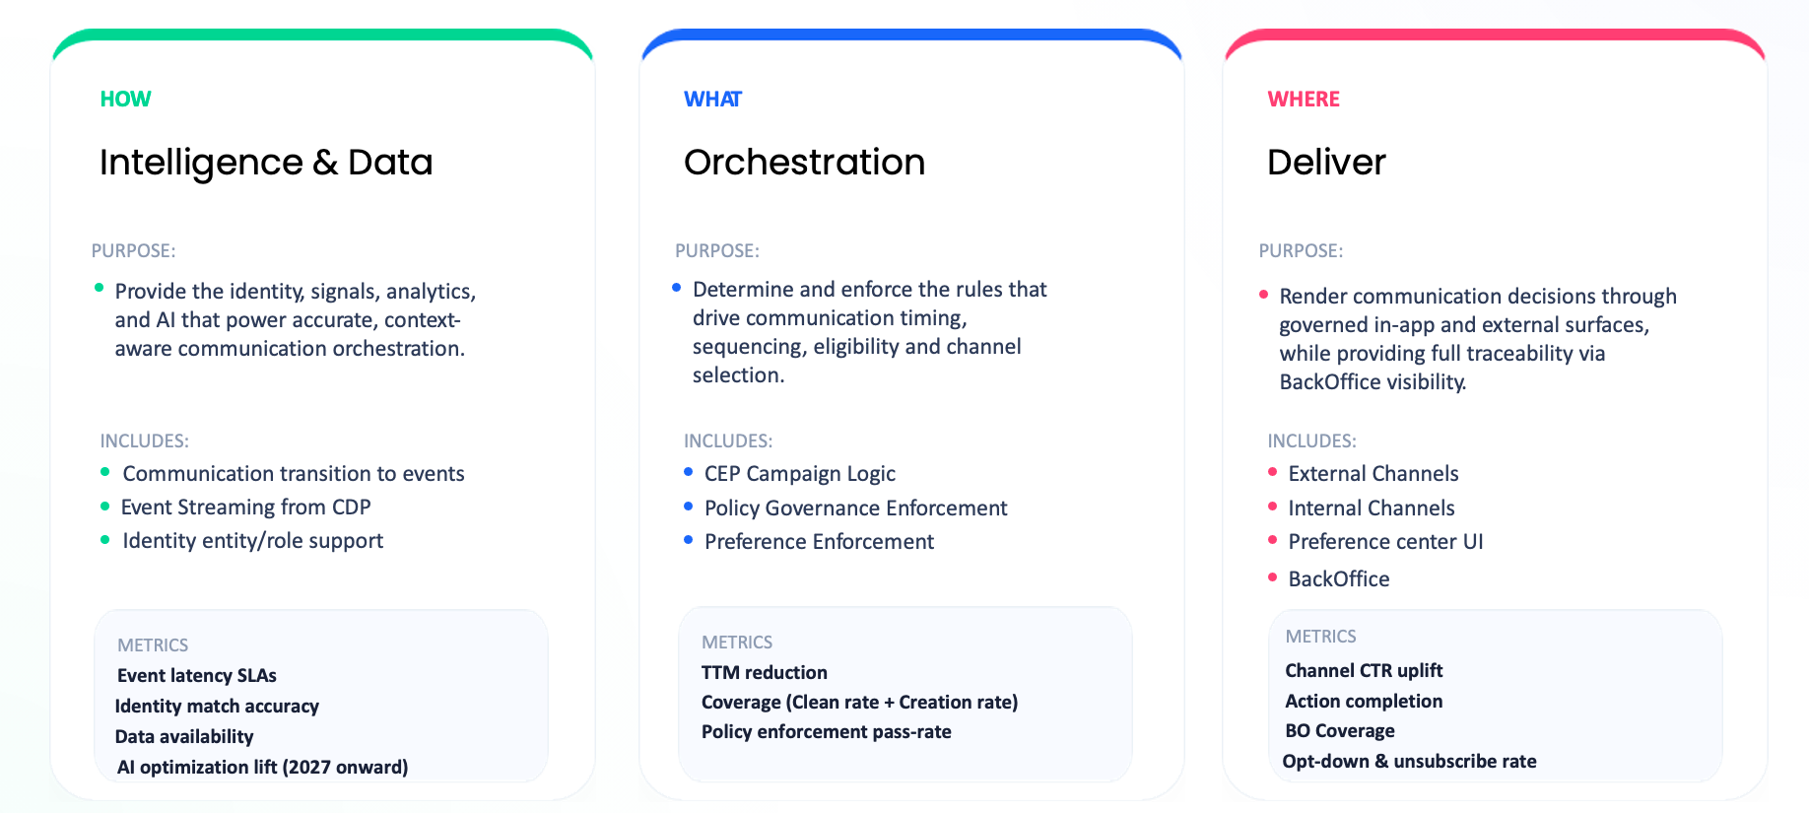

Strategic Pillars (High-Level)
Together these seven pillars create a unified, governed, intelligent communication ecosystem.
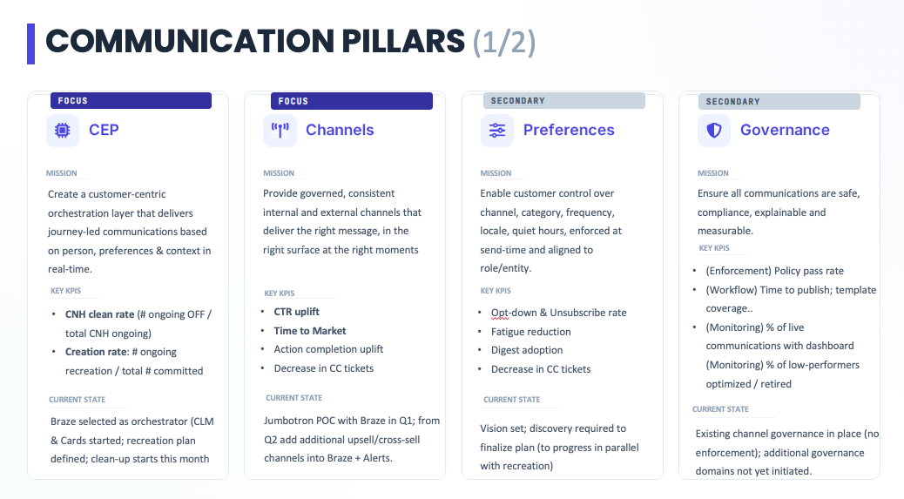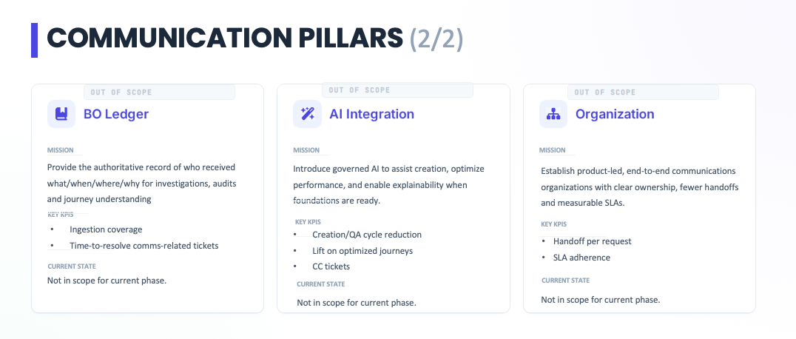

Strategic Outcome (2026–2028)
By 2028, Payoneer will operate a unified, intelligent, compliant communication ecosystem with:
- CEP orchestration of non-security & non-partnership communication (operational, transactional & promotional).
- Measurable lifecycle lifts across onboarding, activation, reactivation, and adoption
- Clear ROI per category and channel with lower unit costs
- Consistent cross-application experiences (MyAccount, Manager Account, and Partner Admin)
- Full auditability and preference-aware delivery-aware delivery
- AI-augmented optimization and predictive, and explainable communications
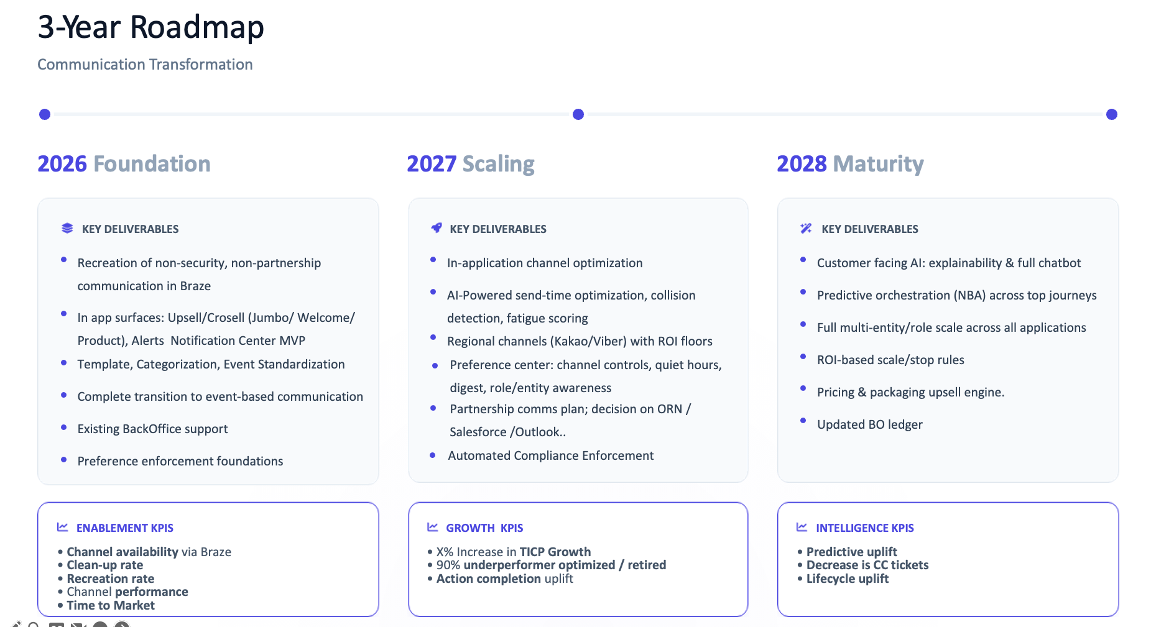
We are transforming 70+ fragmented systems into one governed, real-time communication engine that unlocks multi-entity/multirole experiences and drives efficient growth—upsell, cross-sell, and packaging—while reducing noise, cost, and risk.

2. Background & Introduction
As Payoneer scales into a multi-entity, multirole, multimarket platform, communication must evolve from fragmented, sender-driven activity to centralized, governed orchestration. The industry has already shifted: modern fintech, SaaS, and ecommerce platforms rely on CEP-led, CDP-powered architecture to deliver real-time, compliant, and personalized engagement at scale.
This shift is driven by clear operational requirements:
- Real-time eligibility and decisioning based on role, entity, preferences, and journey state
- Consistent in-app and external channel behavior governed by surface semantics and routing rules
- Reliable send-time enforcement of consent, frequency, quiet hours, and suppression
- Auditability and explainability, where every message has a traceable “who/what/when/where/why”
- Region-ready execution, including China, with equivalent governance and measurement
For Payoneer, this architecture is essential to:
- Support A and B customers with precise, contextual guidance across Accounts and Businesses
- Enable lifecycle acceleration, upsell/cross-sell, and pricing & packaging transitions through eligibility driven next best actions
- Deliver consistent, trustworthy communication across MyAccount, Manager Account, Partner/Admin, and regional experiences
- Reduce operational overhead through reusable governance, templates, and centralized experimentation
- Meet escalating regulatory requirements with predictable, auditable decisioning
In short: centralized CEP orchestration, governed surfaces, a Preference Center, and unified visibility (BO) are structural requirements—not modernization choices. They form the communication backbone needed to support Payoneer’s global scale, growth ambitions, and customer experience expectations.

3. Main Pain Points & Opportunity

3.1 Personas Impacted
A stable, centralized communications foundation enables Payoneer to communicate effectively with customers across transactional, operational, promotional, and educational scenarios. It also strengthens the relationship with all segments of our global user base, with particular strategic emphasis on Top Ideal Customer Profiles (TICPs) — the highest value cohorts driving significant volume and multiproduct adoption.
Strategic Personas
- B2B SMB ROW (TICP: $50K+ monthly volume)
Multi-entity companies with structured teams managing high frequency payments; require role-based communications, permissions aware targeting, and frequency/volume controls to ensure relevance.
- B2C SMEs CN (TICP: $250K+ monthly volume)
Sellers operating at scale, often managing numerous accounts and AHs; require consolidated, context rich, localized (WeChat) communication and manager account aware channels.
- Others
Require transparent, real-time communication personalized by preferences, language, and channel.
Internal Personas
- Product Managers
Own journeys but lack control over triggers, visibility, and governance; depend heavily on engineering and lack in-app surfaces to guide users effectively.
- LCM / Marketing Operators
Manage campaigns with inconsistent templates, fragmented tools, and limited segmentation and lifecycle capabilities; cannot create holistic cross channel journeys to drive growth
- Compliance & Legal
Cannot reliably enforce consent, timing, localization, and regulatory requirements due to missing metadata and lack of communication documentation.
- Care / Risk / Account Managers
Have no unified record of what a customer received, leading to time-consuming investigations and inconsistent customer support.
- Engineering
Supports fragmented systems without clear ownership; backend and frontend responsibilities are separated; infrastructure is not scalable.

3.2 Pain Points — Customer Perspective

Trust & clarity
- Conflicting or duplicated messages undermine trust, leaving customers unsure whether something is required, optional, or even legitimate.
- Inconsistent in-app experiences—different look, tone, or behavior across surfaces—create uncertainty and make customers question whether they’re acting in the correct place.

Timing, channel, and effort
- Poor timing or channel choice (e.g., receiving an email instead of an in-app alert while performing a task) causes customers to miss critical steps, repeat actions, or abandon tasks entirely.
- Scattered, non-prioritized surfaces force customers to hunt across the interface for the next action, increasing frustration and causing unnecessary customer care contacts.

Relevance & personalization
- No multi-role or multi-account awareness leads to generic, irrelevant prompts that do not reflect the user’s actual responsibility—causing confusion, extra steps, and lost confidence in the product. Customers expect communications to adapt to their context: consolidated when they manage multiple accounts, and precisely routed to the correct individual(s) when multiple roles exist.
- Limited localization and content fit (tone, clarity, truncation) makes messages feel unnatural or incorrect—particularly damaging in sensitive markets where precision and trust matter most.

Control & preferences
- Insufficient preference controls (category, channel, frequency, quiet hours) leave customers feeling over messaged, fatigued, or spammed, often driving unsubscribes or disengagement altogether.
- No explainability (“Why did I get this?”) makes messages feel arbitrary or noisy, increasing confusion and support tickets.

3.3 Pain Points — Internal Stakeholders
Product Managers
- No end-to-end visibility to communication data → without a unified view of who received what and why across roles/entities and channels, PMs cannot diagnose drop-offs or optimize journeys.
- No self-serve, governed A/B testing → absence of standardized components and policies blocks cross domain to conduct experiments with measurable lift.
- Low visibility to overall exposure → without a consolidated timeline, PMs cannot verify eligibility/variants per role/entity.
- Fragmented communication real-estate → lacking governed, reusable in-app surfaces and channel patterns, PMs create ad hoc subparts as workarounds, leading to inconsistent UX, duplicated logic, and solutions that do not scale across roles, entities, and applications (requires Channels & Delivery Logic with role/app configuration.
- Cannot target journeys by role/entity → lack of Role-based journeys and Entity-aware tailoring prevents precise prompts and ownership of outcomes.
-based-aware

LCM / Marketing
- Inconsistent templates & tone → impeding Operational Transparency and Feature Adoption journeys at scale.
- Limited segmentation & lifecycle metrics → without a centralized communication hub the lifecycle communication journey isn’t clear, as well as lacking normalized event attributes including role/entity to power Journey Targeting & Personalization.
- Insufficient upsell/cross sell tooling → no governed Promotional paths mapped between channels/preferences/quiet hours/frequency; requires Preference granularity and AI/Next best offer (future).
- Collision & fatigue → absence of Entity-scope fatigue/suppression and Aggregated notifications causes noise and degraded performance.

Compliance / Legal
- Rules not enforced at build/send-time → cannot guarantee legal requirements are implemented including channels, frequency, suppression, consent, naming/metadata or jurisdictional timing/localization.
- Poor audit readiness → no authoritative BO ledger and explainability trail to show who received what and why across roles/entities.

Engineering
- Legacy, service-trigger sprawl → fragmented senders complicate network-based deduplication and capability to support future architecture (entity/role).
- Channel legacy → current method of implementation of channels causes a lot of R&D dependency, complex to sustain with no clear ownership and very slow channel creation TTM.

Care / Account Management / Risk
- Cannot answer “What did the customer receive and why?” → no role + entity-scoped comms timeline and visibility parity.
- Slow, manual investigations → missing BackOffice ledger and aggregated views prevent quick rootcause analysis and clear customer explanations.
- Partner/agent handoffs unclear → no structured Partner/agent communications on onboarding SLAs and ownership transfer.

What fixes these pains (at a glance)
- Lifecycle appropriate channels: Onboarding, Transparency, Adoption, Dropoff, Reactivation-off, Reactivation
- Governance: Frequency, suppression, consent, localization, naming/metadata
- Visibility: BO ledger, role/entity timelines, parity views
- Targeting: Role-based + Entity-aware + Network-aware + Lifecycle-aware journeys
- Channels: Deduplication, role/application-specific routing, AI/NBA (future)-specific routing, AI/NBA (future)
- Data prerequisites: Event bus with entity keys, role/permission graph, preference store, governance layer

3.4 Opportunity
Fixing communication end-to-end unlocks meaningful strategic value for Payoneer. Beyond eliminating today’s fragmentation, a governed, event-driven communication foundation enables the company to operate with clarity, efficiency, and scale across all roles, entities, and applications.
- Accelerate growth and upmarket performance
Deliver precise, contextual guidance that lifts activation, adoption, reactivation, and upsell.
Strengthen pricing & packaging execution through clear eligibility, entitlements, and status updates. Support cross-product expansion with consistent journeys and role-aware next-best actions.
- Strengthen customer trust and reduce friction
Replace conflicting or unclear messages with governed, transparent, preference-aware communication. Ensure customers always know what is happening and why, reinforcing confidence and reducing confusion. Provide consistent experiences across My Account, Manager Account, and Partner Admin.
- Reduce operational cost and internal inefficiency
Lower ticket volume by eliminating noise, collisions, and inconsistent communication behavior.
Reduce investigation time through a unified BackOffice ledger showing who received what, when, through which channel, and why.Minimize engineering and operational overhead through reusable templates, standardized channel behavior, and policy-as-code enforcement.
- Establish a compliant, scalable foundation for global growth
Enforce preferences, consent, jurisdictional rules, and timing constraints consistently across all channels. Add regional or external channels within a governed, vendor-agnostic framework. Strengthen regulatory posture through auditable decisioning and explainable communication.
- Build an intelligence layer that compounds over time
Enable closed-loop measurement from impression → action → downstream outcome. Power ongoing optimization and experimentation with clear KPIs and governed guardrails. Retire low-value communications and scale high-impact ones based on measurable lift and ROI and utilization of AI.

4. Use Cases

4.1 Lifecycle Use Cases
- Onboarding — Increase KYC completion, bank linking, and firs-time payout.
- Operational Transparency — Notify users of account changes, policy updates, and incidents.
- Transactional Transparency — Notify users of account activity such as payment transactions, pending actions and more.
- Feature Adoption (Upsell/Cross-sell) — Target the right users with the right opportunity based on behavior and profile).
- Drop-Off Recovery — Detect stalled users and guide them back to progress.
- Reactivation — Re-engage inactive accounts with personalized journeys.

4.2 Compliance & Governance Use Cases
- Enforce frequency caps, suppressions, channel type, consent, quiet hours, and naming/metadata standards.
- Maintain consistent terminology and jurisdictional/regulatory language across markets.

4.3 Visibility & Operational Use Cases
- Provide a unified BackOffice (BO) ledger for investigation and audits.
- Enable cross-domain experiments with measurable lift tied to business KPIs.
- Centralize localization workflows and translation governance.

4.4 Customer & Segment-Aware Use Cases (A & B focus)
Applies to TICPs (e.g., B2B SMB ROW $~$50K+ monthly and B2C SMEs CN $~$250K+ monthly) and other cohorts; all use cases are role- and entity-aware.

A) Journey Targeting & Personalization
- Role-based journeys — Distinct flows per role (viewer, contributor, manager, owner, card user, custom) with tailored triggers, approvals, and actions.
- Entity-aware tailoring — Personalize content and channels by Business / Account / region (e.g., CN vs. RoW) and Business Group.
- Networka-ware messaging — Differentiate innetwork (intragroup transfers, new entity added) vs. External-network events (payer–contractor pricing change).

B) Aggregation, Preferences & Governance
- Aggregated notifications — Optional daily/weekly digests across selected Accounts/Businesses to reduce noise.
- Selective aggregation — End users choose which Accounts roll into digests; managers may aggregate multiple entities, contributors only those they operate.
- Preference granularity — Per role, per entity settings for types (transactional/operational/security/promotional) and channels (inapp, email, push, SMS, webhook).
- Entity scope fatigue & suppression — Apply send limits/suppression across entity hierarchies to avoid duplicates.
- Localization by entity — Auto-localize by entity jurisdiction/locale; allow global owners to receive English summaries.

C) Transactional & Operational Messaging
- Cross-entity transactional alerts — Payments executed/failed, approvals needed, threshold sweeps—rolled up by Business Group for managers.
- Reusable operational updates — Reuse KYC/periodic review reminders once per Person/Business; avoid duplicate requests across Accounts.
- Policy/limits changes — Notify when role limits or multi-approval rules change (Account vs. Business scope).
- External-network comms — Contractor pricing or marketplace reserve changes, partner onboarding status—sent contextually to linked entities.

D) Security & Incident Communications
- Role-scoped security alerts — ATO/device change for the affected User/Person; managers/owners receive blast-radius summaries across impacted Accounts.
- Entity-level incident posture — If a Business is non-compliant, send freeze notices to relevant Users with remediation steps; if a Person is blocked, inform linked Users/owners with next steps.

E) Back-Office & Support Alignment
- BO visibility parity (customer-mirrored view) — Person → User → Account → Business → Business Group, plus external links, for accurate eligibility and explainability.
- Partner/agent communications — Account activators/partners receive onboarding SLAs, missing-doc prompts, and pass-off confirmations at ownership transfer.
- Role + entity-scoped comms timeline (BO) — BO can see:

F) Channels & Delivery Logic
- Network-based deduplication — If one event affects multiple Accounts in a Business Group, send one consolidated notice to managers; downstream roles get scoped fragments.
- Channel configuration by role — Routing/prioritization adapts by role:
  - Owners/Managers: In-platform (Manager Account) for actions; push/email for high-risk/security; aggregated multi-entity alerts.
  - Contributors: In-app (MyAccount) for action-required events; email for confirmations/receipts.
  - Viewers: Low-impact informational updates only.
  - Custom roles: Channels bound to permission packs (e.g., Treasury manager, AP clerk).
- Channel configuration by application — MyAccount (end-user), Manager Account (multi-entity operators), Partner Admin (activators/partners) each expose the right surfaces and flows for their entity layer (e.g., Manager Account supports multi-account aggregation, Partner Admin supports onboarding notices + webhook flows).
- AI/Next Best Action orchestration (future) — Next-best-action per role/entity (e.g., “Complete KYB for subsidiary X”) with governed guardrails and explainability.

4.5 Illustrative Communication Examples
- Role journeys —
Contributor: “Payment prepared; awaiting manager approval.”
Manager: “3 approvals pending across US-Inc and UK-Ltd.”
- Aggregated digest — “This week: 12 intra-group transfers, 2 Person-level KYB items, 1 policy update; view per-Account details.”
- Selective aggregation — Manager aggregates RoW Accounts into weekly digest while CN Accounts are handled by a local operations team via WeChat.
- Type preferences — Viewer: transactional-only via email; Manager: transactional + operational via in-app + email; Owner: all types including security via push + in-app.

5. Market & Competitor Analysis
Industry direction. Fintech leaders are converging on centralized orchestration for real-time, cross-channel communication and AI-assisted optimization. Independent analysts describe stacks built around unified profiles and journey orchestration (often delivered via multichannel hubs or broader DXPs) to eliminate fragmentation and scale personalization. [blueshift.com], [globalbank…inance.com], [cloud.google.com]

5.1 Why centralized orchestration is now standard
- Gartner: Digital leaders use multichannel hubs to deliver contextually relevant, personalized engagement from a single orchestration layer backed by unified profiles. [blueshift.com]
- Forrester: The shift is from isolated tools to agentic orchestration that weaves data, decisioning, content, and delivery into adaptive experiences. [globalbank…inance.com]
- McKinsey: To scale personalization, firms must strengthen data → decisioning → distribution → measurement foundations—i.e., consolidate communication logic. [cloud.google.com]
Implication for Payoneer: Unify today’s 70+ service-level triggers into one governed orchestration brain to gain consistency, speed, and measurable lift.

5.2 How leading Fintech companies execute communication
Public disclosures rarely list specific CEP vendors. However, observable practices and independent reporting show CEP-like operating models: event-driven, cross-channel, localized, and governed.
Revolut
- Cloud-native, event-driven architecture enabling rapid, automated releases and real-time responsiveness. [forrester.com]
- Strong in-app guidance and data-driven insights—patterns consistent with coordinated, trigger-based journeys. [ft.com]
- Operates across many jurisdictions with growing regulatory automation, implying structured metadata and process controls.
Implication: Reinforces the need for triggered, contextual communications across internal/external surfaces. [revium.com.au]
PayPal
- Finance CX coverage shows a sector-wide pivot to event-driven orchestration (e.g., payment failures, risk signals) to act in real time across channels.
Implication: Validates real-time operational triggers as table stakes in financial services. [braze.com]
Stripe
- Public docs center on webhook-based events for programmatic, reliable transactional notifications—clean, consistent, automated comms.
Implication: Sets expectations for reliable, event-first messaging quality and developer-grade consistency. [docs.stripe.com]
Airwallex / APAC leaders (pattern)
- Industry press highlights rapid adoption of orchestration to unify fragmented systems and support localized channels—especially mobile-first markets.
Implication: Prioritize regional messengers (WeChat/Kakao/Viber), style guides, and deliverability SLOs by market. [journals.plos.org]

5.3 Competitive pattern summary
Market pattern (what leaders do) | Independent evidence | What Payoneer must do
Centralized decisioning & orchestration | Unified profiles + journey orchestration are core to modern stacks. [blueshift.com], [globalbank…inance.com] | Replace 70+ siloed triggers with one governed orchestration layer.
Realtime, event-driven comms-time, event-driven comms | Finance CX moving to event-driven, cross-channel actioning. [braze.com]-driven, cross-channel actioning. | Shift from batch/manual to realtime triggers across internal & external channels.
Localized, multi-channel execution | Orchestration discussed as a unifier for fragmented systems; APAC leaders lean into local messengers. [journals.plos.org] | Build a local-channel portfolio (WA/WeChat/Kakao/Viber), with governance and SLOs.
Conclusion. To match leaders delivering real-time, localized, orchestrated communication, Payoneer should pursue a CEP-first model (with a parallel CH stack), enforce role/entity awareness, and embed governance end-to-end. [blueshift.com], [globalbank…inance.com], [cloud.google.com]

6. Communication Types & Channel Framework

6.1 Type of Communications:
1. Non-promotional

1) Transactional
- Definition: Event-driven messages that confirm or enable a user-initiated or account-critical action. No marketing.
- Primary purpose: Provide proof, status, or required next step to complete the action.
- Typical triggers: Payment sent/received, payout failed/succeeded, invoice issued, card charged, statement ready, tax form available.

2) Operational
- Definition: Ad-hoc, proactive updates about changes or issues that affect the service or account; not tied to a single user action.
- Primary purpose: Maintain transparency, reduce confusion, prevent disruption.
- Typical triggers: Pricing/fee change, T&C update, maintenance/downtime, incident & apology, feature sunsetting/account cleanup, regional update, policy clarifications.

3) Security
- Definition: High-sensitivity communications that protect identity, access, and funds.
- Primary purpose: Authenticate, alert, or block to prevent or mitigate risk.
- Typical triggers: New device/location login, 2FA/OTP, password reset, suspected fraud, account lock, beneficiary or API key changes

2. Promotional (Growth)
- Definition: Messages intended to drive activation, usage, cross/upsell, or brand engagement; requires consent where applicable.
- Primary purpose: Generate incremental adoption and revenue with relevant, benefit-led offers.
- Typical triggers: Lifecycle moments (onboarding/reactivation), eligibility or propensity, seasonal campaigns, partner offers, pricing incentives.

6.2 Types of Channels:
Approach Principles:
1. Scalable, pluggable integration model
Channels (internal and external) must expose a standard integration interface (API, SDK, or component contract) so new surfaces and external messengers can be added, governed, or replaced without re-architecture.
2. Vendor-agnostic orchestration
All channel semantics, templates, and routing rules are owned by the platform and must operate across Braze (RoW), BessChannel (China), or any future CEP.
3. Single place to manage channels
All channel configuration, metadata, templates, routing rules, suppression/fatigue, and permissions must be governed from one orchestration layer.
4. One source of truth + closed feedback loop
Decisioning, delivery, and engagement data must all flow through a unified identity and data layer, with outcomes (impressions → clicks → actions) feeding back for optimization and audit.
5. Clear channel semantics
Each channel and in-app surface has a defined, non-overlapping purpose. Usage must follow governed semantics to avoid collisions, noise, and inconsistent experiences.
6. Preference- and compliance-aware by default
All channels must enforce consent, preferences, quiet hours, frequency limits, and regulatory constraints at send time.
7. Mandatory categorization & metadata at creation
Every communication must be fully categorized when created — not only by high-level type (operational, transactional, promotional), but also by:
- Exact category (e.g., payment confirmation, policy update, KYC reminder)
- Domain ownership
- Lifecycle stage
- Regulatory/compliance requirements
- Priority/severity
This metadata powers eligibility, routing, governance, preference enforcement, BO auditability, and measurement.
8. Compliance with policy & governance + KPI definition
Every communication must comply with its required governance and policy rules (as defined in the Communication Policy Book), and must be launched with a clear KPI.
Performance must be validated and measured against this KPI, with underperforming communications iterated or retired.

Internal / In-Platform Channels
- Definition: Communication surfaces inside the Payoneer platform that deliver contextual guidance, alerts, and tasks at the point of need.
- Primary purpose:
Support actions and understanding directly within the user experience—minimizing friction and driving task completion on the spot.
- Examples of internal channels:
  - Jumbotron / Welcome banner / Upsell/ Cross-sell banner
  - What’s New
  - Page-level alerts and banners
  - Action Center / Notification Center
  - Education Cetner
  - Modals / Tooltips
  - AI assistant prompts
  - Inline notifications within specific product flows
- Typical use cases:
  - Compliance tasks (KYC refresh)
  - Onboarding steps
  - Feature enablement prompts
  - Contextual nudges
  - Product alerts

External Channels
- Definition: Communication surfaces delivered outside the platform, used for confirmations, alerts, notifications, and promotional messaging (when consented). Localization significantly increases clarity, trust, and engagement in global markets.
- Primary purpose:
Reach customers wherever they are, provide timely updates, and support high-urgency or high-visibility communication.
- Examples of external channels:
  - Email
  - SMS
  - WhatsApp
  - WeChat
  - Viber
  - Kakao
  - Push notifications
- Typical use cases:
  - Transactional confirmations
  - Account/security alerts
  - Operational updates
  - Marketing/promotional campaigns (where allowed & consented)

Main advantages of CEP:
- Real-time, event-driven orchestration — event ingestion, segmentation, and triggering in seconds.
- True omnichannel journeys — email, push, in-app, SMS, webhooks with channel-agnostic logic and centralized fallback.
- Experimentation & optimization — native A/B tests, control groups, incremental-lift measurement.
- Deliverability & compliance controls — sender reputation tooling, consent handling, operational safeguards
- Unified profile with preferences — real-time customer state, continuously updated segments, consent/preferences respected.
- Personalization — Cohort definition, precision targeting and dynamic content at execution.
- Analytics tied to outcomes — engagement and conversion tracking with closed-loop measurement.

Communication type \ Advantage | Real-time orchestration | Omnichannel | Experimentation & optimization | Deliverability & compliance | Unified profile & preferences | Segmentation/ personalization | Analytics & outcomes
Transactional | X | X | X? | X | X | X | X
Operational |  | X | X | X | X | X | X
Security | X | X |  | X? | X* | X | X
Promotional |  | X | X | X | X | X | X

All communication types benefit from transitioning to a CEP (Braze). However, security communications have strict requirements around real-time performance, stability, compliance, and reliability. For that reason, they remain out of scope for the initial Braze migration and will continue to require manual handling to support each role.

7. Foundational Principles
The foundational principles guiding this strategy reflect both industry best practice and Payoneer’s specific needs:
- Buy, don’t build: Leverage enterprise-grade CEP and data platforms rather than custom solutions
- Centralization: One orchestrated system enabling consistency, governance, and optimization
- Supports A & B needs: Role-based communication and manager-account communication
- Implementation of guardrails & governance: Make communication lean, effective, and safe
- Cost effective: Validate channel and communication ROI; remove low-value interactions
- Take ownership: Communications must be product-led and data-driven
- Customer-first: Clarity, transparency, proportionality, and preference-aware experiences
- Compliance & trust by default: Auditable, explainable, and enforceable orchestration
- One journey, not many messages: Optimize sequences, not isolated touchpoints
- Localization & accessibility: Native language, cultural sensitivity, inclusive design
- Measure, learn, and iterate: Continuous experimentation as standard practice
- Scalable operations: Reusable templates, components, events, and automation

8. CDP Requirements for CEP Orchestration (ROW + CH)

8.1 Purpose & relationship to CEP
The Customer Data Platform (CDP) is the data source of truth for orchestration. It aggregates and standardizes events and attributes from applications and services (behavioral, transactional, operational, risk/compliance, and business segmentation). Braze (CEP) subscribes to this unified data to execute real-time, role/entity-aware journeys, enforce preferences and governance, and measure outcomes end-to-end.
High-level flow:
Event & attribute ingestion → identity resolution & entity graph → real-time segmentation & eligibility → publish to CEP (profiles, events, audiences, traits, preferences) → CEP triggers journeys → results/engagement back to CDP & BO for analytics and audit.

8.2 Identity & Entity Model (must-have)
- Person ↔ User ↔ Account ↔ Business ↔ Business Group relations
- Role mapping per User×Account (viewer, contributor, manager, owner, card user, custom role)
- External network links (payer, contractor, marketplace, partners)
- Jurisdiction & locale at entity level (e.g., CN vs. RoW), with inheritance rules
- Privacy/consent status and opt-in provenance per identity and per channel
Acceptance: deterministic identity resolution configured; role graph available to CEP in near-real time; lineage for consent.

8.3 Event Model (required to power journeys)
- Lifecycle & transactional events: onboarding milestones, KYC/KYB, document requests, payments (initiated/sent/received/failed/under_review/declined/resolved/cancelled), card events, limits/approvals changes.
- Operational events: pricing/T&C updates, incidents, maintenance windows, policy clarifications, feature sunset.
- Security metadata (non-content) for BO visibility: login/device change, OTP sent, account lock, fraud signal (payload minimized).
- Engagement & channel feedback: delivered/open/click/bounce/complaint/suppressed/aggregated; in-app impressions & action outcomes.
Acceptance: event schemas versioned, immutable; per-event entity scope (User/Account/Business/Group) and role eligibility flags; latency SLA.

8.4 Profile & Traits (for segmentation/personalization)
- Behavioral: last action timestamps, frequency, recency, product usage counters, eligibility flags (e.g., card eligible).
- Business segmentation: ICP/TICP membership, region, tier, pricing package, risk tier, industry.
- Journey state: current step, last step outcome, next required action, suppression windows, fatigue score.
- Localization: preferred language(s), country, timezone; entity-level locale overrides.
Acceptance: CEP can fetch traits at decision time; traits updated within SLA after source change.

8.5 Preferences, Consent & Governance Signals
- Consent state per channel and per communication category (transactional/operational/security/promotional), with quiet hours and role- & entity-aware overrides.
- Fatigue counters and suppression windows (entity-scope aware, e.g., “count across all CN Accounts”).
- Priority & proportionality policy tags to inform CEP conflict resolution.
Acceptance: preference enforcement occurs at send-time; CDP exposes a single, authoritative preference object to CEP.

8.6 Audience & Eligibility Publishing
- Computed audiences (e.g., “Managers with >$50k monthly volume in RoW, not completed KYB”) published to CEP.
- Per-event eligibility (who should receive a message) and explainability payload (why/why not), with role and entity scope.
Acceptance: CEP receives audiences and eligibility diffs; publish cadence supports near-real-time use cases.

8.7 Upgrade / Pricing & Packaging:
- Eligibility freshness SLA (calc→publish), Recommendation accuracy (accepted vs. served), time-to-upgrade (first exposure → effective change), ARPU / margin lift post-upgrade, decline-reason coverage (policy/compliance/collections), governance adherence (quiet hours, suppression, role/entity eligibility), and closed-loop attribution from variant exposure to realized value.

8.8 Data Movement, Latency & Quality
- SLA tiers:
  - Tier 0 (critical triggers): ≤5 seconds source→CDP→CEP (Examples: payment failued, payment receieved, document require, KYC step completed, approval needed)
  - Tier 1 (journey triggers): ≤60 seconds (Examples: onboarding step completed, usage threshold, reaction trigger)
  - Tier 2 (audiences/traits): ≤15 minutes (Examples: segments - managers with >$monthly volume; usage % - number of payments this month )
- Quality controls: schema registry (standardized); contract tests (can’t change for example ‘payment_status’ without validation); dead-letter replay (fails = automatic retry) ; PII handling; consent gating at ingestion (events are ingested only with the consent state).
- Observability: freshness, drift, error budget dashboards; per-event lineage.

8.9 Outputs & Feedback Loops
- To CEP: profiles, traits, audiences, eligibility, real-time events (behavioral and application), preferences, policy flags.
- From CEP: engagement metrics (delivered/open/click/suppression), variant exposure, downstream action signals.
- To BO Ledger: normalized, role/entity-aware send records (who/what/when/where/why), including interface the customer encountered, content, policy packs applied and preference snapshot at send-time.

8.10 China (CH) Considerations
- Parallel CDP/CEP stack that respects data residency, local channel ecosystems, and performance constraints.
- Harmonized schemas & semantics to maintain comparable journeys and analytics across RoW/CH.

8.11 KPIs
- Freshness SLA adherence by tier; audience publish lag; preference enforcement accuracy (>99.9%); eligibility error rate; variance in role/entity targeting accuracy; closed-loop attribution coverage (% journeys with outcome link).

9. Product Strategy & Approach

9.1 3-Year Vision
Vision: Make communications an intelligent growth engine—predictive by design, governed by default, and explainable end to end—delivering the right message, to the right role and entity, in the right channel, at the right moment and optimize across onboarding, activation, adoption, retention and growth.

Key outcomes
- Intelligent orchestration: predictive send-time, anomaly detection for fatigue; automated guardrails.
- Full multi-entity & role scale: messages dynamically reflect entity policy, user role, and relationship; consistent audit trails across all sends.
- Closed-loop optimization: journey-level ROI, marginal lift per step, automated suppression for low-value comms.
- Operating leverage: minimal manual ops; catalog-driven builds (journey blueprints, policy packs, content components).
North-star outcomes by end of 2028
- Unified orchestration: ≥85% of non-security comms orchestrated via CEP with journey-level governance.
- Lifecycle impact: +20–30% improvement in first-action completion for action-driven activity & promotional communication; +10–15% retention uplift in targeted cohorts.
- Operational efficiency: >50% faster time-to-market for new comms; ≥40% template reduction; measurable drop in incidents/duplicates.
- Compliance & trust: Zero critical breaches attributable to comms; auditable decisioning for every send.
- Scalable architecture: Support for multi-entity and multi-role (owner, employee, approver, payer, etc.) across internal and external channels.

Guiding Principles for Execution
  - Policy before scale
Governance rules, metadata standards, naming conventions, and compliance packs must be defined and enforced upfront, not retrofitted later.
  - Event-driven communication (“No event → No communication”)
All journeys operate on role- and entity-aware event contracts with defined SLAs, ensuring accuracy, timeliness, and eligibility consistency.
  - Deprecate as we recreate
As each communication is rebuilt in the CEP, its legacy CNH counterpart is turned off immediately to prevent dual-system drift.
  - Enable safe self-serve within guardrails
Product, LCM, and domain owners can create, localize, and update communications — but only within enforced templates, metadata, policy-as-code, permissions, and routing rules.
  - Measure outcomes by design
Every communication must declare a KPI (CTR, action completion, downstream lift, etc.) and be measured, optimized, or deprecated based on performance.
  - Invest only in “new” CEP-orchestrated communications
All future enhancements are built through the governed CEP layer.
No additional investment goes into CNH or legacy senders beyond temporary fixes to prevent customer harm.
  - Unified data layer across ROW and China
Identity, events, traits, preferences, and governance signals come from a single source of truth—consumed equally by Braze (ROW) and BessChannel (China).
  - Experimentation by default (A/B and holdouts)
Every governed communication must be A/B-testable using standardized components and templates, supporting continuous improvement and clear ROI.
  - Real-time vs near-real-time clarity
Not all communications are real-time.
The system follows explicit event tiers:
    - Critical real-time (seconds): payments, KYC milestones, required actions
    - Journey triggers (sub-minute): onboarding, usage thresholds, reactivation
    - Audience/traits (minutes): segments, thresholds, states
Each tier has defined latency expectations.
  - Integration with 3rd-party data and triggers
The orchestration layer must support external triggers from partners, marketplaces, financial stack systems, and risk/compliance engines to power cross-ecosystem journeys.
  - Categorization & metadata are mandatory at creation
Every communication must be fully categorized — by type, exact category, lifecycle stage, domain, regulatory requirements, priority/severity — to power eligibility, routing, preferences, BO visibility, and measurement.
  - Compliance with policy & governance
All communications must pass policy-as-code validation at build and send (consent, preferences, quiet hours, frequency caps, naming, metadata, regulatory requirements, routing, surface semantics).
  - Standardized, pluggable integration model for all channels
Internal and external channels must expose a standard integration interface (API, SDK, or component contract) so surfaces and messengers can be added or replaced without re-architecture.
  - Vendor-agnostic by design
All governance, metadata, templates, journey blueprints, and policy-as-code logic must live outside any single vendor so orchestration remains portable and multi-vendor by default.

9.3 Main Pillars
- CEP (ROW + China parallel CEP)
The unified orchestration engine for all non-security communications—enabling real-time journeys, precise segmentation, and consistent execution globally. A parallel CEP for China ensures local channel support and compliance with regional requirements.
Example of Journey personalization:
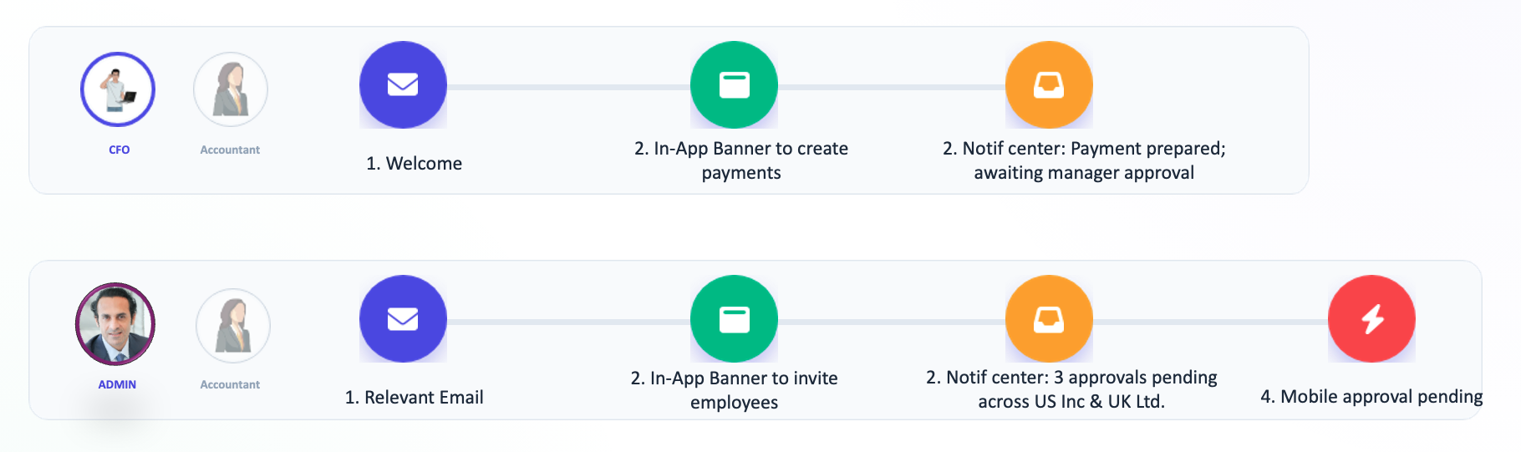
- Channels (Internal & External)
Defines and manages all communication surfaces—in-product and out-of-product—with a clear purpose per surface, governed usage, and measurable KPIs. Supports localization at scale and with the vision of per-application configuration (e.g., MyAccount / Manager Account / Partner Admin).
Conceptual UI:
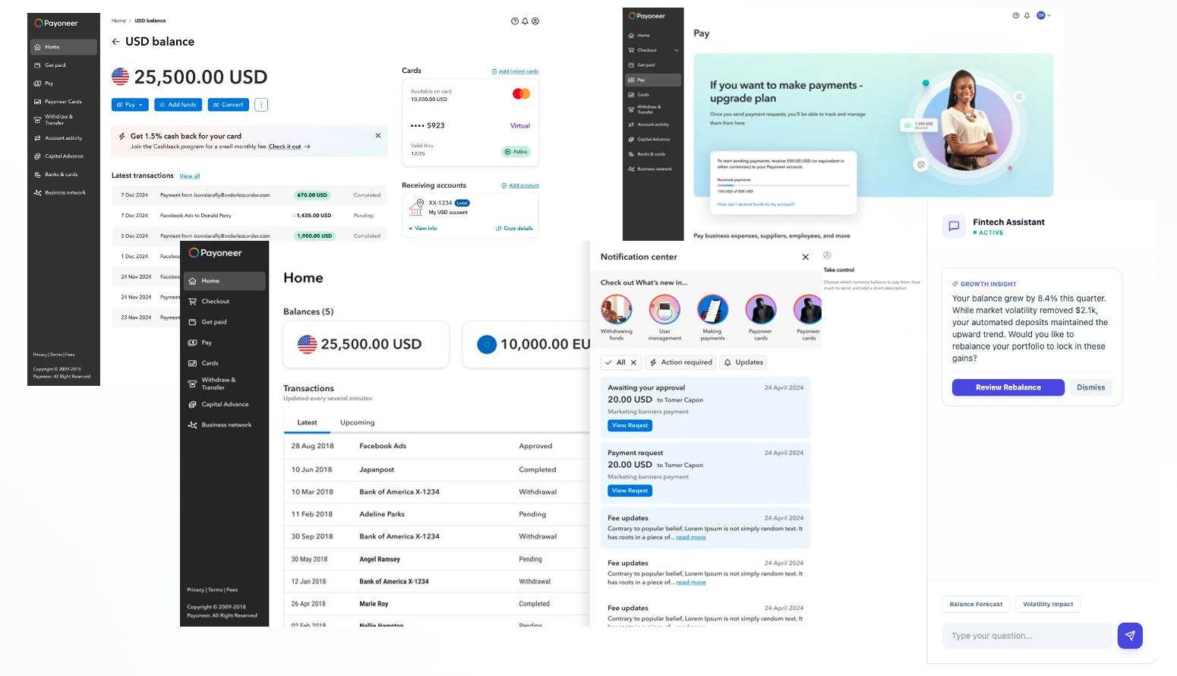
- Preference Center
Gives customers transparent control over how and when they are contacted, enforcing consent, frequency, quiet hours, and channel preferences—with full support for multi-entity setups and role-specific settings.
Conceptual UI:
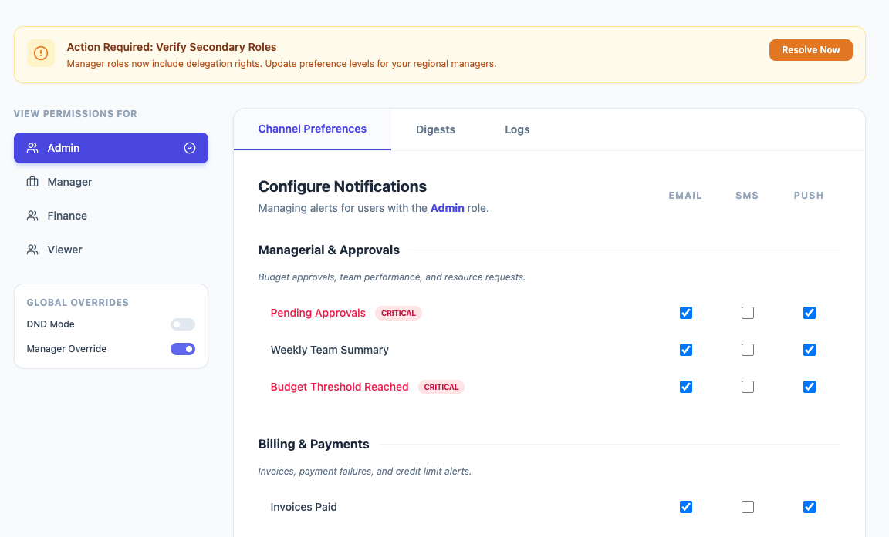
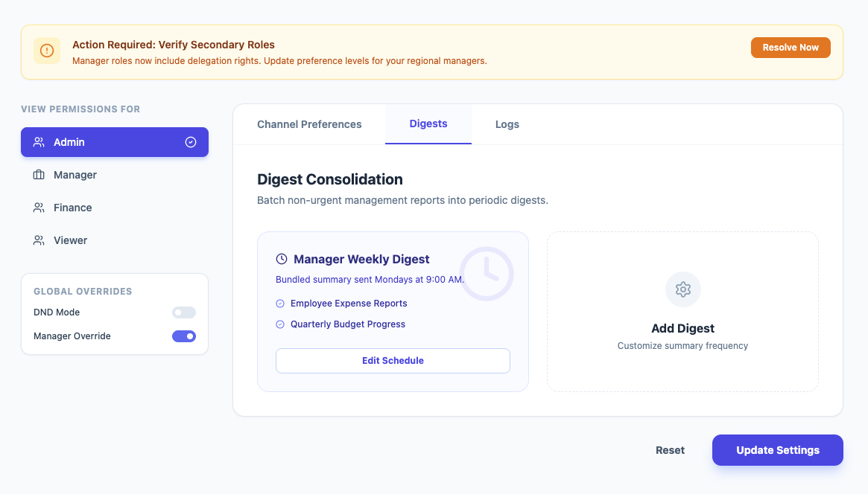
- Governance & Compliance
Establishes enforceable rules and ways of working that make communications safe, consistent, and compliant—covering metadata standards, approvals, frequency caps, localization requirements, and policy-as-code checks. Includes CEP roles & permissions, governance by communication type, a complex-flows framework, and channel governance.
- BackOffice Ledger
The authoritative system of record for every communication—enabling investigation, auditability, endtoend journey understanding, compliance checks, and crossteam transparency through a role/entityaware timeline of “who received what, when, through which channel, and why.”
Conceptual UI:
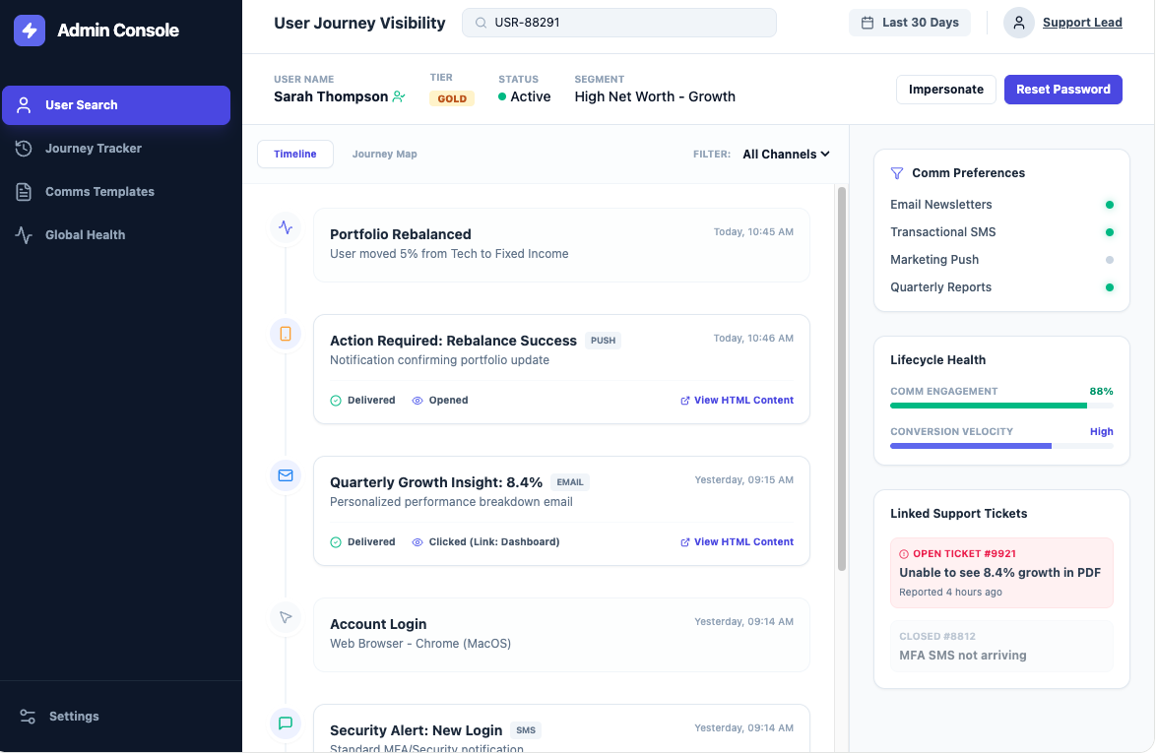
- AI Integration
Enhances creation, optimization, and orchestration with guardrailed AI—and, over time, becomes an in-app channel for explanations (“why did I get this?”), task guidance, and personalized support, aligned to preferences and policy.
- Organizational Structure
A product-led operating model with clear ownership, roles, and pods that manage orchestration, channels, governance, content operations, and investigation workflows end-to-end—reducing handoffs and improving time-to-value.

10. Cost & Investment Envelope (2026–2027)

10.1 Summary (current → projected)
- Current Braze cost (annual): $350K
- Max esposure (if migrating ‘as-is’): $558K
- Delta (ceiling): +$208K/year
The +$208K/year represents a worst-case ceiling, assuming today’s volume and fragmentation are moved into CEP without cleanup, governance, or channel-mix changes.
The strategy explicitly avoids an “as-is” lift by applying structured recreation, governance, and channel optimization to reduce unnecessary volume while enabling scale.

10.2 Existing Contractual & Operational Cost Obligations (2025–2026)
Item | Annual Cost | Deadline | Implication
Acoustic (Email Service Provider) | $80,000 / year | Contract ends Oct 2026 | Remaining transactional emails must be recreated within CEP before contract end; otherwise Payoneer will need to extend or renegotiate the agreement.
KTLO for Legacy Services (CNH + related senders) | ≈ 1 developer FTE (continuous) | Nov 2026 — .NET10 upgrade deadline | All remaining legacy communication services require a full upgrade to .NET10 if not deprecated in time. Delays directly increase engineering cost and extend KTLO.

Why this matters: These create hard cost deadlines that increase urgency. Faster deprecation of legacy senders and migration of required flows reduces avoidable cost entering 2026–2027.

10.3 Key cost drivers (why ‘as-is’ grows cost)
If lifted “as-is,” cost growth would be driven by a few core structural issues:
- Ad-hoc communications disproportionately drive volume, often broadcast broadly due to missing targeting controls.
- Service-level sprawl (76 triggering services) causes duplication, inconsistencies, and over-volume.
- Minimal aggregation/digests and weak suppression/fatigue controls increase redundant sends and push more traffic external instead of in-app.
These are the structural sources of the +$208K ceiling.
10.4 Cost model: increase vs. decrease levers
The financial plan keeps the program cost-neutral to cost-reducing by combining (1) bounded growth levers and (2) enforced volume-reduction levers.
TABLE 1 — COST INCREASE LEVERS
Cost Increase Lever | Explanation | Estimated Annual Impact
“As-is” migration ceiling | If today’s 397M sends moved without cleanup, contract reaches max tier. | + $208K (worst-case)
External channel expansion | More use of SMS/WhatsApp/WeChat/Kakao/Viber depending on journey expansion. Baseline annual spend is currently being retrieved (Finance). Expected: ~1 new channel/year if ROI-positive. | Variable (ROI-gated)
More addressable variants (role/entity) | More personalized versions may increase message count if not suppressed/digested. Assumes suppression/digest strategy → low incremental volume. | Low (suppression minimizes this)
MAU/profile tier growth | More users exposed to in-app surfaces can increase Braze MAU counts, affecting tiering. Today’s estimated MAU exposure = ~2M; contracted tier supports up to 4M → no cost increase expected in next 1–2 years. | Tier-based (depends on MAU growth)
China parallel stack | Separate orchestration required for China adds small enablement overhead. Cost impact expected to be minor; validation in progress with China Eng. | Small overhead
Regulatory external flows | Certain communications must remain email/SMS. Already part of external-channel baseline; considered fixed expected cost. | Fixed, expected cost
TOTAL Estimated Increase (realistic, not worst-case) | Reflects the probability-weighted portion of the $208K ceiling + small overheads. | + $40K–$120K

TABLE 2 — COST DECREASE LEVERS (Updated With Assumptions)
Cost Decrease Lever | Explanation | Estimated Annual Savings
Shift informational traffic to in-app & digests | Moves non-regulatory content to in-app; reduces external variable cost. Assumes 3–5% shift in informational volume. | 3–5% → $6K–$10K
Suppression, fatigue, preferences | Avoids unnecessary sends and over-messaging across roles/entities. Assumes enforcement via policy-as-code at send-time. | 5–10% → $10K–$20K
Deduplication & collision prevention | Prevents double-sends and conflicting notifications. Enabled by unified orchestration record. | 2–3% → $4K–$6K
CLM reduces follow-up loops | Collects info upfront → prevents back-and-forth “missing info” comms. Assumes measurable reduction for top flows post-CLM. | 5–10% → $10K–$20K
Catalog cleanup (low-value comms) | Removes dead, low-frequency comms; reduces clutter and prevents accidental sends. | 2–5% → $4K–$10K
Ad-hoc communication reduction via governance & policy | Ad-hoc comms (clean-ups, pricing updates, T&Cs) = ~50% of all sends. Governance and correct data (via CDP) allow these communications to be sent more conservatively and only to the right audience, reducing unnecessary broadcasts and preventing apology comms sent afterwards. | 5% → $10K–$15K
Avoid CNH deprecation + .NET10 upgrade | Removing CNH before upgrade avoids one engineer worth of maintenance. Finance to convert 1 engineer/year into $. | Value = 1 engineer/year
Avoid Acoustic renewal | Acoustic contract ends Oct 2026; not renewing saves cost. | $80K/year (hard saving)
Operational efficiency (engineering time) | 75% less engineering effort per comm. Ops time saved (non-variable). | Ops saving (not variable cost)

Net Summary Cost-Increase:
- Cost-Increase: +$40K–$120K
- Cost-Decrease: $124K–$161K + 1 engineer/year cost avoided
- Net expected outcome: ~$4K–$121K net savings/year, plus avoided 1 engineer/year
10.5 Investment line-items
- Braze annual license & usage (profiles/MAU, Email, Push, Webhooks, archive, support plan)
- People: Braze-certified developer/architect, FE developers for in-app surfaces, data PM and solutions roles
- Parallel China stack enablement (data residency + channel readiness)
Note: CDP investment is foundational and part of a broader platform roadmap; it is not included as a comms-specific incremental line item.

10.6 Financial guardrails & acceptance
- No “as-is” migration. Every migrated comm must have clear purpose, audience, governance, and KPI.
- Volume commit controls with fail-safes for spikes.
- Channel-level SLOs: deliverability, latency, and cost per outcome by market.
- Quarterly clean-rate / creation-rate reviews to avoid dual-system drift.
- Sunset gates tied to recreation milestones.

10.7 KPIs to track cost–value balance
- Clean rate (legacy offboarding)
- Creation rate (CEP recreation progress)
- Unit economics (cost per delivered, per click, per action) by channel/market.
- Volume mix shift (% in-app vs. email/SMS; % aggregated/digested).
- Channel creation TTM reduction, Dev hours avoided.
- Lifecycle lifts (KYC completion, first payout, reactivation, adoption)—funding the program.
- CLM efficiency: # of follow-up messages avoided due to up-front data collection; % of journeys completed without human back-and-forth.

10.8 Communication Growth & ROI Framework
Growth in communication volume is allowed only when it is ROI-positive and governed.

A. Expansion principles
- Net-value rule: Each incremental communication or channel must increase a lifecycle KPI (activation/adoption/retention) or reduce operational cost (e.g., fewer tickets) after governance costs.
- Fatigue-aware: Expansion is gated by entity-scope fatigue and quiet hours adherence.
- Preference-first: Do not expand volume where consent/opt-down signals indicate saturation.
- Premium-channel prioritization: Premium or higher-cost channels may be enabled selectively for TICPs or high-value segments, where elevated service, localization, or immediacy materially improve lifecycle KPIs or support packaging/cross-sell value.

B. Channel ROI KPIs (per market/segment)
- Cost per action (CPA-comm) and marginal lift vs. holdout.
- Deliverability/Reach KPIs: inbox placement (email), send success (messengers).
- Engagement: impression → click/CTA → downstream action rate, time-to-action.
- CX/Trust: complaint rate, unsubscribes/opt-downs, spam reports, policy exception rate.
- Operational: ticket deflection, ticket creation decrease, BO investigation time reduced.

C. Scale/stop rules (per channel)
- Scale up when: CPA-comm improves QoQ, marginal lift is statistically significant, fatigue < threshold, deliverability SLOs met.
- Pause/trim when: fatigue or complaint rate exceeds threshold, negative lift, or cost per action deteriorates for two consecutive periods.
- Rotate to in-app/digests when: informational updates show low action rate but high open rate.

D. Governance hooks
- Policy-as-code blocks expansion when eligibility or preferences cannot be validated at send-time.
- BO visibility required for every incremental flow (auditable “who/what/when/why”).
- Quarterly channel review: keep/kill/scale decisions based on ROI dashboard.

11. Execution Plan (Pillar by Pillar)
(Metrics, big rocks, plan, decisions/risks/open questions)

11.1 Pillar 1 — CEP (ROW) & Recreation

A vendor-agnostic, future-proof CEP foundation
Although Braze is the CEP selected for the current implementation, the architecture is deliberately vendor-neutral. All core assets—identity and event models, metadata and taxonomy, governance rules (policy-as-code), templates, journey blueprints, and channel semantics—are designed to operate across any enterprise CEP.
This approach ensures:
- No dependency on a single vendor
- Capability to operate multi-CEP environments (e.g., Braze for ROW with a separate stack for CH)
- Smooth transition to alternative or additional CEPs in the future
- Preservation of governance, journeys, and orchestration logic even as underlying components evolve
In practice, Braze functions as the first implementation of a centralized orchestration layer, while the platform model, data contracts, and operational framework remain fully portable, providing long-term flexibility and strategic independence.
Journey-led recreation approach
Non-security ongoing communications undergo journey-led recreation in the CEP (scope → cleanup → recreation), ensuring only fit-for-purpose messages persist. Legacy CNH communications are systematically deprecated immediately following successful CEP go-live, eliminating redundancy and preventing dual-system operation.

A) Success Metrics & OKRs
- Channel Creation Velocity: 80% of placements/templates for new channels delivered within the 3-day SLA.
- Orchestration:
  - 90% CNH clean rate (non-partnership, non-security)
  - 70% recreation coverage
- Governance Enforcement: ≥99.9% preference & compliance enforcement at send-time.
- Channel Enablement: Number of channels available via CEP out of 6 defined channels.
- Experimentation (2027 target): ≥70% of tests self-served (A/B + holdouts under guardrails).

B) 2026–2027 Big Rocks
- Foundations: Establish the identity, events, and metadata model for role/entity-aware orchestration (versioned event contracts; policy tags).
- Recreation Phase I (H1–H2 2026): Prioritized journey recreation for BizApps/My Account, CLM, Cards, and Add Bank; apply reusable template families and compliance packs; deprecate corresponding CNH sends in-sprint.
- Cross-product journeys: Introduce Next-Best-Action decisioning and multi-entity/role eligibility via CDP audiences and traits.

C) Focus
Current customer-facing communication senders: CNH (transactional/operational/promotional), Marketo (promotional/some operational), ORN (CC/CSM), Salesforce (GTM/account workflows), Outlook emails (Risk/ad-hoc), WeCom (China).
Execution focus (2026–2027):
- CNH is the primary scope for non-security, ongoing communications; Email + Push are the first channels to be recreated.
- LCM is working to migrate Marketo communications to Braze under a parallel, LCM-owned plan.
- In-app real-estate is not lifted ‘as is’; selected placements (e.g., banners/content cards) are powered by Braze (in terms of UI) to reduce channel creation TTM and enable governed self-serve; other in-app channels and patterns are redesigned with governance rules, and measurement and connected to Braze for content management and centralization.
- ORN/Salesforce/Outlook ad-hoc flows are brought under governance visibility (BO ledger) and considered for future recreation once owners, purpose, and frameworks are defined.

D) Plan — Journey-led recreation (not migration)
1) Layered execution (Q1–Q3 2026)
- Scope (Q1): Concentrate on ongoing communications, Channels = Email + Push. Exclude: Security (remains on dedicated rails), Partnerships (requires discovery first). Enforce ownership: only customer-facing domains (BizApps, Ecosystem, CLM) that will own their communication; unknowns are reassigned before build.
- Clean-up (Q1): Remove <10 sends/year (unless regulatory), remove 10<x<100 sends/year (unless critical), merge duplicates; keep only a lean, validated catalog for recreation.
- Recreation (Q2–Q3): Rebuild per a standardized Journey Blueprint (events → eligibility → templates → channel hierarchy → legal components → NBA). Deprecate CNH equivalents immediately after CEP go-live to avoid drift. Apply policy-as-code at build- and send-time (naming/metadata, consent and preferences, fatigue/suppression, priority).
2) Frameworks & assets used in every flow
- Journey Blueprint: shared, version-controlled “When/Where/What/How/Who.”
- Reusable components: template families (Email/Push), content blocks (status badges, receipts, KYC prompts), compliance packs (pre-approved language, locale timing, audit checklist), channel hierarchy modules (primary/secondary/fallback + failover).
- Event & data contracts: versioned specs; No event → No communication; phased Aurora + Braze SDKs for reliable real-time triggers, segmentation, and suppression logic.
3) Channels & fallbacks
- Email and Push are mandatory channels to recreate for transactional and operational communications—Email serving as the primary web channel and Push as the primary mobile channel.
- In-app is redesigned; selected real-estate leverages Braze components (e.g., banners/content cards) for speed and governance.
- Fallback rules: Transactional → Email → Notification Center → SMS/Push (regulatory/urgent only). Security continues on dedicated rails; metadata mirrored to the BO ledger for visibility.
4) Operating model & monitoring
- PM accountability for product-journey communications; LCM co-owns promotional.
- BO ledger as the authoritative record of who/what/when/where/why, with the applied policy pack and the preference snapshot at send-time.
- Dashboards & KPIs: TTM, action completion, engagement, segmentation precision, noise reduction, compliance pass rate, rework rate.

d) Risks, Decisions, Open Questions

Risks
- Event readiness & latency: Delays or gaps in event availability jeopardize the “No event → No communication” principle and stall journey triggers.
Mitigation: tiered SLAs, contract tests, and interim fallbacks for non-critical sends.
- Governance bypass via legacy paths: Partial adoption (or easy access to old senders) can re-introduce duplicates and noise.
Mitigation: policy-as-code at build/enforcement in Braze, deprecation gates, and BO monitoring.
- Capacity constraints across domains: Concurrent clean-up → recreation → deprecation requires sustained PM/LCM/Eng/Compliance bandwidth.
Mitigation: phased sequencing, shared KPIs, and sprint-aligned decommission gates (formal checkpoints).
- Regulation/Compliance dependency: Embedding compliance into communications—via compliance-by-design, reusable compliance packs, and journey sign-offs—requires clear ownership and SLA-bound review cycles.
Mitigation: Phase sequencing, shared KPIs, standardized templates, pre-approved language libraries, and an exception workflow with expiry.

Decisions
- China architecture: Executed separately using two CEPs (Braze and Besschannels) to satisfy data-residency and channel requirements.
- Marketing platforms: Marketo/Acoustic migration milestones and success criteria are owned by LCM/Marketing and tracked on their parallel plan.

Phase II — Pending Decisions / Next Scope
- Centralization of additional senders: Define the path (and timing) for ORN / Salesforce / Outlook communications to enter governed visibility and, where justified, recreation/centralization.
- Ad-hoc operational comms governance: Set standards and owners for non-ongoing operational messages (e.g., pricing updates, policy changes), including criteria and approval flow.
- Partnership communication plan: Establish requirements and the recreation framework for partner/eco-system communications.

11.2 Pillar: Channels (Internal & External)
Channels define all communication surfaces—internal and external—and ensure every message appears in the right place, with the right purpose, governed rules, and measurable outcomes. This pillar creates a unified channel ecosystem powered by CEP orchestration, standardized components, and a clear hierarchy of communication surfaces.
a) Success Metrics & OKRs
- External CTR: +3% baseline uplift in 2026; +10–15% in 2027 with localization, quiet hours, and send-time optimization in Tier-1/2 markets.
- Action completion: Achieve a +10% uplift in 2026 for defined promotional journeys (acquisition, upsell, cross-sell), increasing to +15–20% in 2027 with enhanced personalization, role/entity targeting, and CEP-driven segmentation.

b) 2026–2027 Big Rocks

Internal Channels — 2026 H1
Implement Braze’s in-app SDK, enabling the use of Braze Content Cards, Banners, and additional components as first-class, native in-product surfaces. Define the placement taxonomy, tagging standards, allowed message types per surface, and routing hierarchy. Enable the Jumbotron through Braze-powered UI components.

Internal Channels — 2026 H2
Connect What’s New and the Welcome Banner to Braze for eligibility and experimentation. Deliver the Notification Center MVP (business actions, alerts, What’s New), supported by required instrumentation.

External Channels — 2026 H1
Standardize transactional and operational Email and Push templates under consistent governance, metadata, and localization rules.

External Channels — 2026 H2
Prioritize two regional messengers (e.g., Kakao, Viber) based on ICP footprint, regulatory feasibility, and channel ROI.

Internal Channels — 2027
Introduce activity preferences and role/entity-aware channel controls. Launch AI Assistant v1 to provide contextual explanations (“Why did I get this?”), guided tasks, and lightweight in-flow support. Expand internal surfaces with proactive product alerts, modular upsell blocks, and cross-application placement unification.

External Channels — 2027
Add WeChat, Kakao, Viber where strategically relevant. Implement market-specific quiet hours, and scale send-time optimization and cross-channel sequencing using Braze’s orchestration capabilities.
c) Current State of Internal & External Channels (2025–2026)
Channel / Surface | What Was Done | How It’s Managed Today | Results & Insights | Limitations (incl. availablebutnotusable)-but-not-usable) | Governance Status | BO Visibility | Forward Plan (2026–2027)
Notification Bell / Notification Center | Legacy UI & BE; limited experiments | Triggered via code or Braze webhook (performanceheavy, suboptimal)-heavy, suboptimal) | 24–25% click bell; ~44% click a notification (dependent on message type) | Old BE; cannot reliably detect badge; inconsistent message types; limited telemetry; not CEPintegrated-integrated | None | Partial | Full UI/BE redesign; CEP-based eligibility & suppression; complete instrumentation (impression → click → action)
Jumbotron | Policy tightened in 2024 | Managed via BO; LCM avoids BO due to audience-selection complexity | High exposure but historical misuse for non-promotional flows | BO friction; not CEP-governed; legacy FE; no experimentation framework | Partial | No | Replace with Braze components; enforce strict promotional-only policy; CEP templates + CTR/impact measurement
Alerts | Warning, Info & Success variants implemented | Triggered via code or BO (BO rarely used) | “Warning” alerts show 73% CTR; +10% doc completion | Partial template family; not CEPsegmented; legacy BE; overuse risk-segmented; legacy BE; overuse risk | Strong | Partial | Standardize full alert family; enable CEP eligibility/governance; UX refinement; connect marketing use-cases to CEP
What’s New | One-off experiment; hard-coded | Hard-coded FE carousel; no backend logic | High exposure & CTR; weak downstream progression | No eligibility; no deeplinking; breaks with Aurora; should pair with Tours; not maintainable-linking; breaks with Aurora; should pair with Tours; not maintainable | Partial | No | Rebuild with Braze components; CEP eligibility; couple with Tours; track action completion
Tour Guide | Old version removed; Aurora version ungoverned | Triggered adhoc via code-hoc via code | No consistent results; fragmented adoption | No queuing; no segmentation; no A/B testing; high misuse risk | None | No | Adopt thirdparty tool (Amplitude or similar); implement governance; integrate CEP for targeting & sequencing-party tool (Amplitude or similar); implement governance; integrate CEP for targeting & sequencing
Welcome Banner | One experiment showed strong lift | Product logic in code (no CEP integration) | +35% to +92% CTR (desktop); mobile downlift | UI standards missing; insights from experiment not implemented; not CEP-governed | Partial | No | Standardize UI; migrate to CEP templates; test mobile-first variants
FirstUse States-Use States | Extensive A/B tests with strong gains | Implemented via Design System templates | +32% senders; +108% opt-in; −29% time to action | Missing lifecycle states; inconsistent adoption; telemetry varies | Partial | Partial | Expand lifecycle states; enforce CEP eligibility; standardize instrumentation
Email | Long history; fragmented | Mix of legacy services, BO, and some CEP | Varies by domain | Template sprawl; inconsistent localization; weak governance | Weak | Yes | Full CEP standardization; introduce locale playbooks; enforce deliverability SLOs & ROI
Push | Under-governed | Partially CEP-driven | Limited structured testing | No priority model; inconsistent routing; risk of duplications | None | Partial | Apply priority matrix; CEP suppression; enforce timetoaction KPIs-to-action KPIs
Regional Messengers (WeChat / Kakao / Viber) | Minimal usage | Adhoc, no governance-hoc, no governance | N/A | No market strategy; no SLOs; no consent/localization rules | None | No | Build regional strategy; define ROI KPIs; implement quiet hours & regulatory compliance flows

Payoneer’s communication surfaces operate at mixed maturity. Some channels—such as Alerts, simplified Welcome Banners, and First-Use States—show strong performance and clear user behavior improvements. Others (Notification Center, What’s New, Jumbotron, Tours) exist but rely on legacy UI/backend, lack eligibility logic, or are available but not used due to back-office audience selection complexity, hard-coded logic, or missing instrumentation.
Across internal surfaces:
- Several were introduced as one-off experiments and remained without governance.
- Notification behavior is inconsistent across apps and surfaces.
- Telemetry (impressions, badge exposure, click → action) is unreliable or missing.
- Routing is not prioritized, causing collisions and shadow channels.
Across external channels:
- Email is heavily used but fragmented.
- Push lacks priority rules vs. email.
- Regional messengers require strategy, governance, and ROI criteria.
This baseline underscores the need for standardized semantics, CEP-driven eligibility, policy-as-code, and Braze-based in-app components for a unified experience.
d) Channel-by-Channel Overview & Forward Plan

Internal & External Channels — Current State → Future State Table

e) 2026–2027 Plan

1. Internal Purpose-Built Surfaces
Each internal surface is assigned a clear, non-overlapping remit, forming the semantic model for all in-app communication. This enables consistent routing, reduces collisions, and supports user cognitive expectations across platforms.
Primary Surfaces
- Alerts → Account-impacting and actionable changes (e.g., status, blocks, risks, required steps).
- Notification Center → Business actions and updates; consolidated, structured feed.
- Banners → Contextual nudges embedded within workflows and pages.
- What’s New → Discovery of new features, capabilities, and relevant announcements.
- Jumbotron (future Braze component) → Top-tier promotional placement for high-impact product or feature releases.
- Tours / Walkthroughs → Deeper guidance; sequenced assistance; coupled with What’s New for feature adoption.
- Welcome Banner → Activation and onboarding milestones aligned to first-use and early-life behaviors.
- First-Use States → Structured onboarding at the feature/product level, guiding users through initial configuration, thresholds, and value-enabling steps.
Missing / Future Real-Estates
To complete a unified communication surface model, additional in-app placements must be introduced. These surfaces address current gaps in contextual guidance, lifecycle transparency, and lightweight system signaling.
1. AI Chatbot (Education + Support + Action)
- Real-time contextual explanations (“Why did I get this?”)
- Guided tasks, troubleshooting, and decision support
- Lightweight actions (eligibility, required docs, renewals, upgrades)
- Multi-entity, role-aware assistance surface
2. In-Product Notifications (Micro-Alerts / Snackbars)
- Lightweight, non-disruptive notifications not tied to Notification Center
- Used for confirmations and low-severity updates
- Requires clear separation from Alerts and Banners
3. Transparency Component (Cross-Lifecycle Status Surface)
A unified, reusable component that communicates user-visible status across multiple journeys.
Used for:
- Onboarding lifecycle — verification state, missing items, next steps
- Payments lifecycle — sent → pending → review → completed → requires action
- Packaging/Pricing lifecycle — current package, eligibility, limits, upcoming changes
- Regulatory flows — compliance holds, remediation paths
- Upgrade/downgrade journeys
- Tier, entitlement, and usage thresholds
Remit:
- Provide customers with consistent, governed, transparent status
- Reduce UI fragmentation and eliminate shadow messaging
- Support AI explanations and CEP-driven eligibility rules
- Standardize timing, language, state transitions, and severity patterns

4. Overlay / Modal (Blocking & High-Importance Surfaces)
A controlled, interruptive real-estate for:
- Critical account-impacting events
- Regulatory notices
- Security and compliance actions
- Mandatory flows (e.g., KYC step required)
- Payment failures or irreversible actions
5. Regional External Channels (TBD)
Final selection (WeChat, Kakao, Viber, WhatsApp, etc.) will be prioritized based on TICP footprint, regulatory feasibility, and ROI thresholds.

6. Routing Hierarchy & Conflict Rules
To ensure the right message appears on the right surface at the right time, all in-app communication follows a platform-wide priority hierarchy:
Critical → Blocking Task → Journey Nudge → Discovery
- Critical messages override all others (e.g., account-impacting, payment or compliance risks).
- Blocking Tasks surface when the user must complete a required action to proceed.
- Journey Nudges guide users toward beneficial behaviors or optimizations.
- Discovery surfaces new features and general informational content.
When multiple communications are eligible at once, higher-priority messages suppress lower-priority ones, and are routed to their designated surfaces (Alerts, Banners, Notification Center, etc.).
The CEP enforces:
- Priority resolution
- Suppression windows and fatigue rules
- Quiet hours
- Proportionality (avoiding overload)
- Eligibility based on entity, role, and journey state
This framework prevents collisions, eliminates shadow channels, and guarantees consistent in-app communication across all products and surfaces.

7. Instrumentation Baseline
Every communication surface must emit a minimal, consistent set of signals to enable measurement, optimization, and governance. These signals ensure every message is traceable, explainable, and tied to lifecycle outcomes.
All surfaces must emit:
- Impression — the message was displayed
- Click — the user interacted with the message
- Action Completion — the downstream behavior occurred
- Eligibility Reason — why the message was shown to this user
- Role / Entity Context (where applicable) — who the message applied to across Business / Account / User scopes
KPI Requirement
Every message must carry a defined KPI (e.g., action completion, lift, CTR, adoption).
If the KPI does not meet expectations, the communication must be iterated, optimized, or deprecated as part of continuous improvement and governance.
8. Channel Policy, Localization & Governance
Payoneer currently maintains an internal Communication Policy Book (Communication Policy Book.docx), which defines baseline governance for existing channels. As channel orchestration shifts to CEP and in-app surfaces expand, this policy must be broadened and formalized into a full, multi-channel operating standard.
The expanded policy will include:
- Journey-level communication frameworks
(rules per lifecycle, entity/role, and use-case)
- Channel-specific standards
(placement semantics, routing, priority, metadata, templates)
- Localization and market-level requirements
(tone, translation guidelines, regulated phrasing, timing constraints)
- Operational thresholds & ROI criteria
(CPA-comm, marginal lift, fatigue limits, quiet hours, suppression logic)
- Measurement & iteration rules
(every message must define a KPI and demonstrate value before scaling)
This expanded governance model ensures all channels—internal and external—are consistent, compliant, measurable, and optimized across markets and lifecycle stages.

9. CEP Integration for In-App Surfaces
Once SDK is integrated, Braze Content Cards, Banners, and Alerts become native in-app components, enabling:
- Eligibility
- Suppression
- Targeting
- Segmentation
- A/B testing
- Consistent look & feel across platforms
- Reduced FE cost and faster channel creation TTM
10. Additional Requirement: Centralization Must Support Entity, Role, Eligibility & Pricing Use-Cases
As all channel management centralizes into CEP, the system must support:
- Entity-level messaging (Business, Account, User, Group)
- Role-based eligibility (Owner, Manager, Contributor, Card User, Approver, etc.)
- Pricing & packaging flows, including upgrade eligibility, entitlements, and multi-entity implications
- Regulatory/market-level policies tied to entity or role
- Next-best-action frameworks dependent on role × entity combinations
- Cross-channel preference enforcement at role/entity level
This ensures in-app surfaces and external channels deliver precise, personalized messages aligned to customer context and business structure.
f) Decisions, Risks & Open Questions

Decisions
- Product Communication is the end-to-end owner of all internal and external communication channels and surfaces, including governance, semantics, templates, routing rules, and CEP integration.
- Platform Engineering owns deliverability and infrastructure for all external channels (Email, Push, SMS, WhatsApp/WeChat/Kakao/Viber, etc.), including SLOs, scaling, and latency pathways.

Risks
- China operating gap: The China communication model and required team are still pending, delaying alignment with the global CEP strategy and limiting regional orchestration capabilities.
- Legacy channels: Existing legacy channels lack ownership, are unmaintained, and highly complex. This creates recurring operational overhead (triage, investigations, bugs) and slows progress toward a unified communication architecture.
- High Aurora dependency: Surface activation, events, and eligibility logic depend heavily on Aurora timelines, which may impact sequencing for in-app surfaces, routing, and observability.
- BackOffice (BO) scope gap: BO was not originally included as part of the communication team’s scope or roadmap, resulting in limited auditability, inconsistent visibility over send events, and unclear responsibility for BO insights and tooling.

Open Questions / Outstanding Decisions
- China model: What is the final team structure, ownership model, and technology stack required to support CH orchestration with data residency and regional channel requirements?
- Legacy channel retirement: Which legacy surfaces must be actively deprecated first to unblock SDK rollout, reduce noise, and prevent shadow-channel behavior?
- BO integration: What is the long-term ownership model for BO as a communication audit and visibility tool (e.g., Product Communication vs. Platform Engineering)?
- Cross-team adoption: How do we ensure complete adherence to new channel semantics, routing rules, and governance workflows across all domains?

11.3 Pillar: Preference Center
The Preference Center is the central control layer through which customers manage how, when, and through which channels they receive communication—personalized by entity, role, communication category, frequency, and channel availability. It transforms communication into a customer-driven, transparent, and compliant system, powered by CEP enforcement.
a. Success Metrics & OKRs
- Opt-down vs. unsubscribe
Reduce unsubscribe rates in 2026–2027 by offering finer controls (category, frequency, channel), allowing customers to adjust communication rather than opt out entirely.
- Fatigue reduction
Year-over-year decline in fatigue-based suppressions as preferences are honored more accurately; improved engagement among opt-down users.
- Role- & entity-aware preferences
Live by 2027; measurable increases in task completion, onboarding progress, and payment/document workflow completion for entity- or role-specific categories.
- Enforcement accuracy
Achieve >99.9% enforcement accuracy across preferences, quiet hours, category rules, and channel selection at CEP send-time.
b. Current State (2025–2026)
The current Preference Center is not integrated with Braze and does not support real-time preference enforcement. Opt-in/out changes and consent updates are processed manually and are not evaluated at CEP send-time. As a result, preference settings are not consistently honored.
Configuration options are minimal. The existing interface supports very limited communication or channel preferences, mainly around promotional timing. It does not support configuration of:
- Communication categories
- Quiet hours
- Frequency
- Channel-level controls
- Role-level preferences
- Digest settings
- Localization defaults
Structural gaps impair functionality:
- Communications are not consistently tagged with category, purpose, or metadata
- No authoritative inventory exists for messages across channels
- Category mappings are not maintained
- Routing hierarchy and semantic rules are not enforced during creation
- Supports very limited communication or channel preferences
A fully functional Preference Center becomes possible only once CEP orchestration, metadata standards, and communication governance are in place.
c. 2026–2027 Big Rocks
2026 H1
- Align opt-in/out definitions, consent types, and communication category taxonomy with CEP
- Begin audit-grade consent capture
- Enforce preferences at CEP send-time
2026 H2
- Define frequency models for high-volume categories based on journey recreation in Braze
(for example, adding frequency caps for payment confirmations once those journeys are rebuilt)
- Implement CEP-based suppression and fallback logic for preference-restricted categories
2027 H1
- Introduce channel-level settings, quiet hours, and locale hierarchy (brand → region → account)
- Establish default patterns for different user profiles and regions
2027 H2
- Launch role-aware preferences (Owner, Manager, Contributor, Card User, Approver)
- Deliver multi-category digest options (payments digest, account digest, product updates digest)

d. Plan

1. Single Source of Truth
- Store all preferences within a unified identity model, ensuring availability of role/entity context
- Provide real-time preference states to CEP for routing, suppression, and eligibility decisions
- Maintain full audit history for compliance and regulatory traceability

2. Category Framework

Define an intuitive set of communication categories such as:

Account status and compliance

Payments

Product updates

Education and tips

Promotions

Pricing and packaging

System notifications
Each communication maps to exactly one primary category, enabling consistent opt-down behavior, digest grouping, suppression rules, and regional overrides.

3. Role-, Channel-, and Frequency-Aware Enforcement
CEP enforces preferences using:
- Role context (Owner / Manager / Contributor / Card User / Approver)
- Entity context (Business / Account / User)
- Communication category
- Channel preferences
- Frequency and quiet hours
- Fatigue and proportionality rules
- Regulatory exceptions with logged expiry
Messages that violate preference state are rejected during CEP pre-flight checks.

4. Digest Model
Enable digest functionality for:
- Business activity
- Payments and balances
- Account status
- Product updates
- Promotional content (optional)
Digests reduce noise and support large multi-entity accounts.

5. Competitor Preference UI
Mercury:
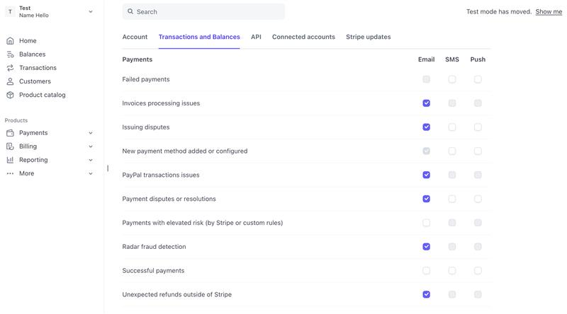
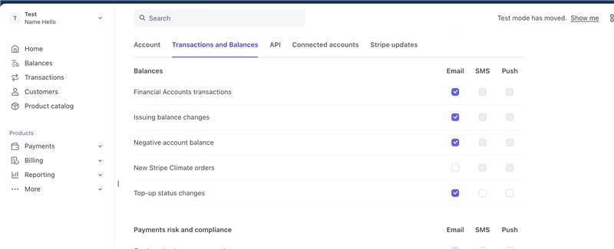
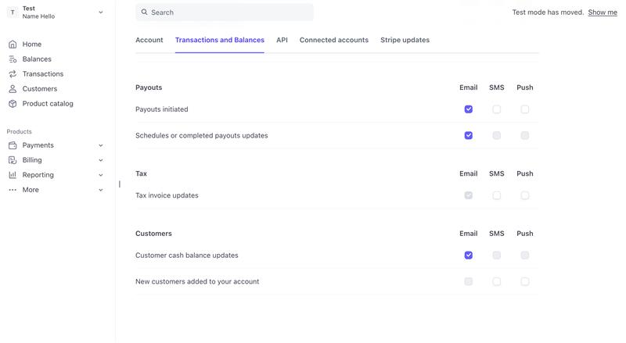
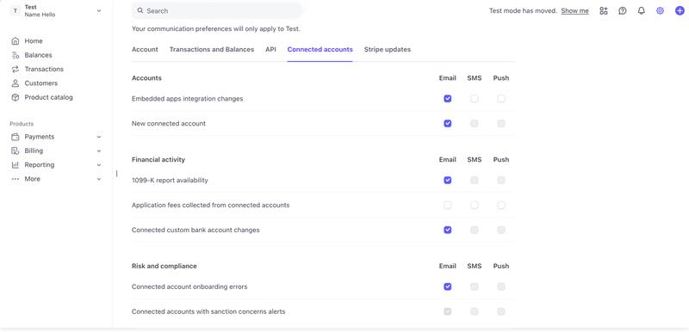
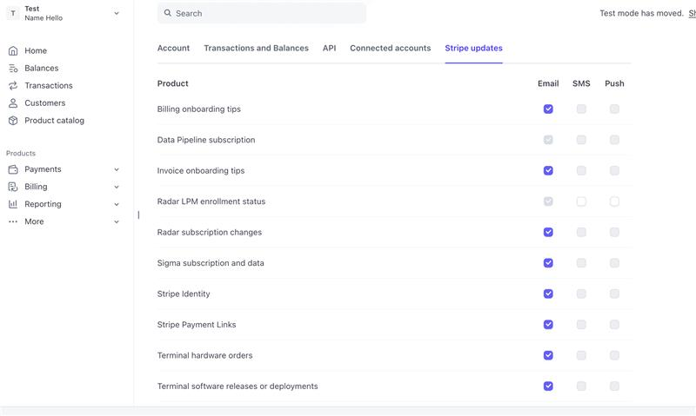
Wise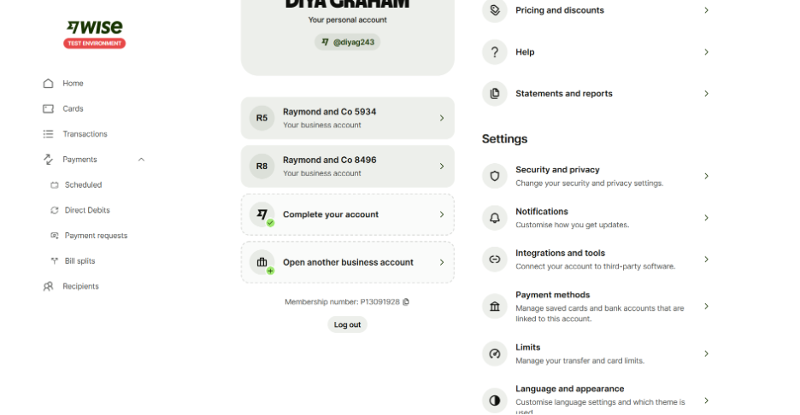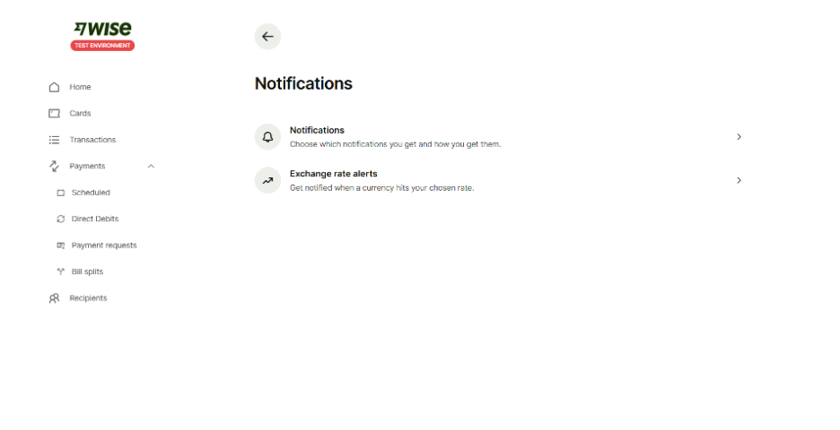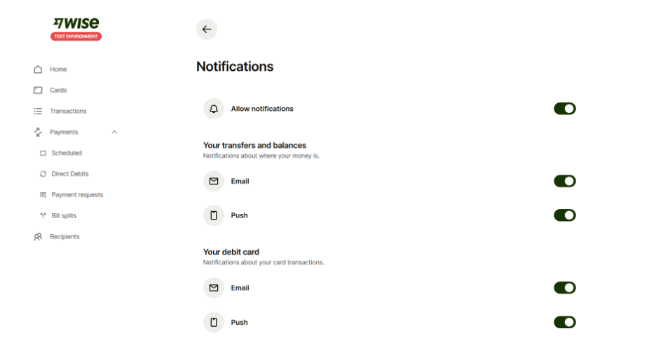
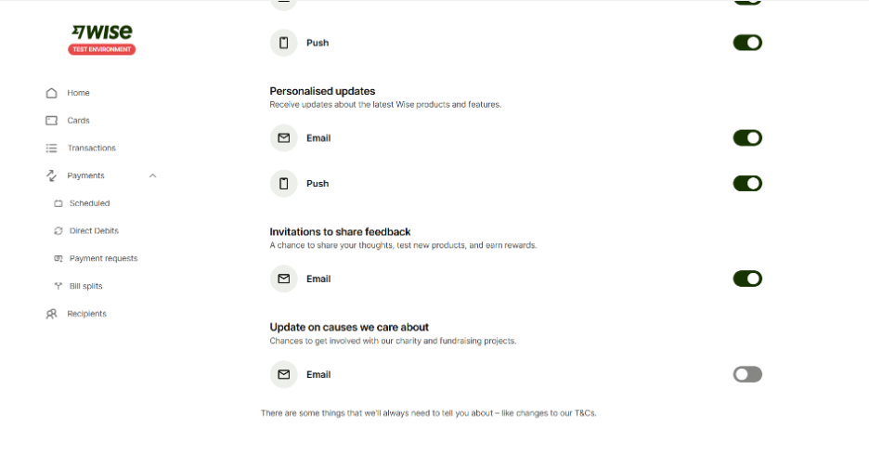

Airwallex
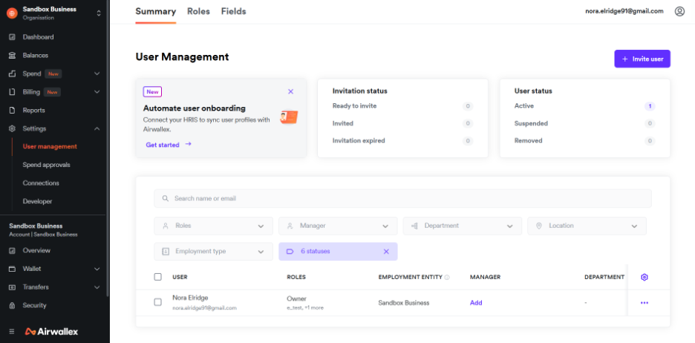
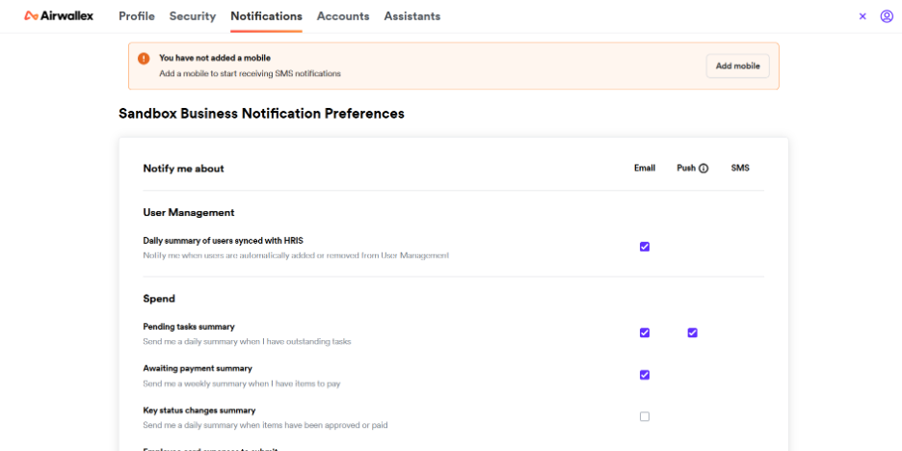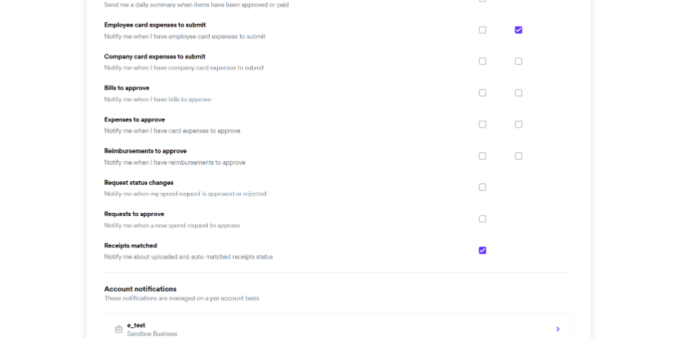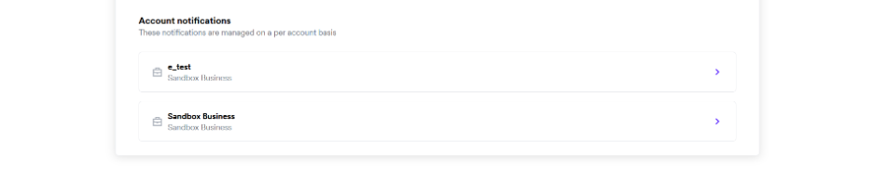

PayPal
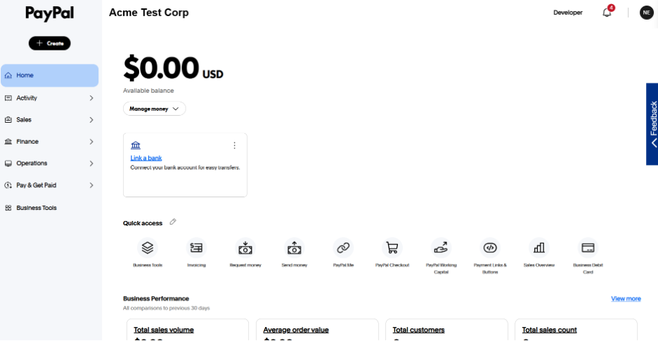
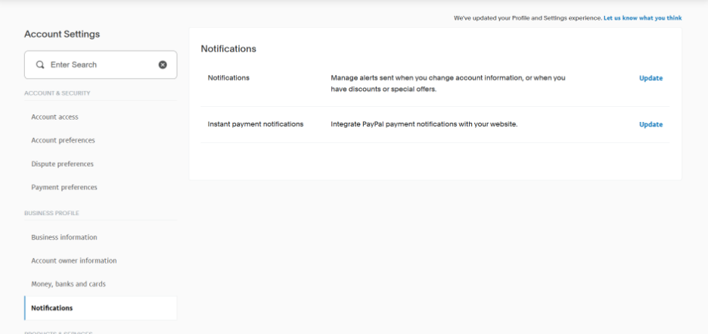
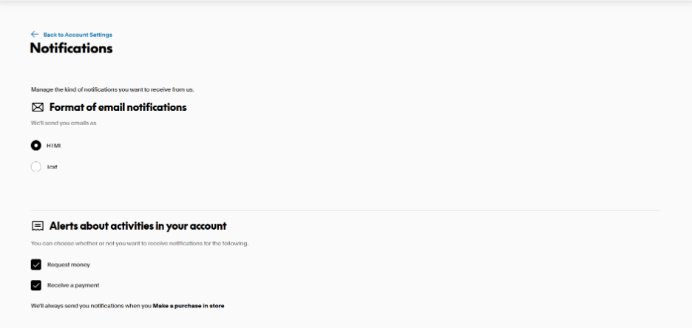
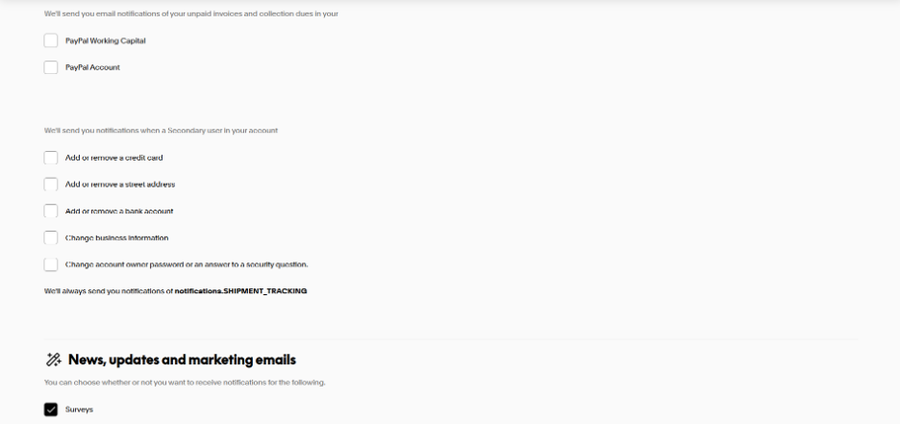
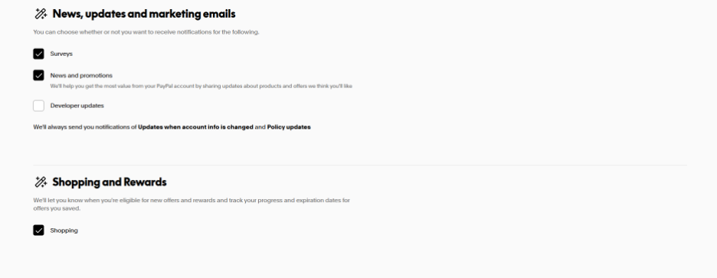

6. Payoneer Preference Center UI
Surface preferences through:
- Unified Web & Mobile settings
- AI Assistant (for example, “Pause promotional updates,” “Show only account-critical messages”)
- Role-based visibility and cross-application behavior
Entity Owners set the default communication preferences for the entire Business or Account. These defaults determine the communication types that apply to all roles within that entity.
When a new role is created, the system assigns a default communication profile that only the Entity Owner can modify. This ensures that:
  - Communication types (e.g., transactional, operational, promotional, pricing & packaging)
are governed at the entity level and remain consistent with business rules.
  - Individual users can customize their personal channel preferences (e.g., email, push, in-app, regional messengers) but cannot override entity-level communication type settings.
In multi-application environments (such as Manager Account or Partner Admin), the Preference Center applies the same role- and application-aware rules. Each application retrieves the unified preference state through CEP and displays only the options relevant to the user’s role and the functions available in that environment.
[Insert Wireframe]
e. Decisions, Risks & Open Questions

Decisions
- Placement and UX for the Preference Center across Web, Mobile, Manager Account, and Partner Admin
- Ownership for category taxonomy, consent types, and phrasing standards
- Digest cadence (daily/weekly/monthly) and eligibility logic
- Definition of quiet hours, frequency controls, and channel-level rules per market
Risks

Legacy Preference Center architecture requires a full redesign to support application-aware and role-aware behavior.

Preference capabilities (frequency, digests, channel-level settings) depend on recreation of communications in Braze

Delays in role model readiness may postpone rollout of role-aware preferences.

Localization and regional compliance requirements may create inconsistency if not standardize.

Regulatory constraints may conflict with frequency limits or quiet hours.

Legacy senders bypassing CEP may cause preference drift until fully decommissioned.

Open Questions

Whether certain regulated markets require mandatory messages regardless of user preferences

Alignment of brand-level vs. product-level categories across different regions

Whether role- or entity-based preferences require market-specific legal review

How digest preferences should surface across Manager Account, Partner Admin, and other admin tools

11.4 Governance & Compliance
Governance ensures every communication—internal or external—is consistent, compliant, explainable, measurable, and intentionally designed. It defines the rules for how communications are created, approved, routed, personalized, delivered, and monitored across Payoneer’s ecosystem. Governance eliminates shadow channels, enforces policy-as-code through CEP, and ensures every journey aligns with regulatory expectations, user preferences, and business objectives.
Governance is organized into five domains, each representing a critical control layer.

Governance Domain 1 — Policy & Standards Governance
This domain defines the rules of the communication ecosystem and ensures they are codified, enforced, and consistently applied across journeys, channels, and surfaces.
- Core components include:
  - Communication Policy Book → AI Governance Agent enforcing rules in real time
  - Policy-as-code: governance encoded directly into CEP, templates, metadata, and validation steps
  - Communication taxonomy (category, purpose, lifecycle stage, priority, regulatory flags)
  - Naming standards, tagging rules, metadata schema
  - Channel semantics and surface definitions
  - Localization, translation, and regulatory phrasing standards
  - Consent and preference rules (quiet hours, frequency, category selection)
  - Suppression logic, fatigue rules, proportionality rules
  - ROI thresholds and marginal-lift requirements per category (promotional and operational)
  - Mandatory KPI linkage for every communication asset
- What “policy-as-code” means:
Governance rules become system-enforced constraints, not optional guidelines. If a rule is violated, the CEP or template validation engine blocks the message before it can be published or sent.

Governance Domain 2 — Workflow & Journey Governance
This domain governs how communication is created, who participates, and how approval flows operate. It covers internal R&Rs, content governance, compliance requirements, and structured recreation.
- Core components include:
  - Roles & responsibilities across Product Communications, LCM, Legal, Compliance, Domains, Platform Engineering
  - Creation workflow: creation → review → compliance → metadata → QA → publish → deprecation
  - Compliance checkpoints: regulated phrasing, timing rules, jurisdiction constraints
  - Template & content governance: standardized components, approved building blocks, reusable legal language
  - Triggering events & eligibility rules
  - Journey state models, transitions, and lifecycle definitions
  - Variant logic and next-best-action design
  - Legacy deprecation rules and decommissioning sequencing
  - Quarterly journey audits
  - Communication Recreation Framework (Communication Recreation Approach – January 2026.docx) for complex or cross-domain journeys
  - Multi-team alignment for high-risk or high-impact journeys
- Braze CEP roles & permissions (governed here):
  - Who can create vs. edit vs. publish journeys
  - Who can create or modify templates
  - Who can access messaging components
  - Who can modify segmentation, frequency, or suppression rules
  - Who can approve and who has publishing rights
  - Separation of duties (no single user can create + publish + approve)
  - Environment separation (Dev / Stage / Production)
  - Permissions for accessing reporting, dashboards, and send histories
This ensures least-privilege access, prevents unauthorized sends, and provides full auditability.

Governance Domain 3 — Channel & Surface Governance
This domain governs where communications appear and ensures routing adheres to the platform’s hierarchy and semantics.
- Core components include:
  - Surface definitions: alerts, banners, tours, overlays, transparency components, What’s New, Jumbotron (Braze), snackbars, in-product notifications
  - Routing hierarchy: Critical → Blocking Task → Journey Nudge → Discovery
  - Conflict resolution rules (higher priority suppresses lower priority)
  - Surface-based eligibility rules and placement restrictions
  - Enforcement of surface semantics for each category (e.g., Alerts = account-impacting only)
  - Localization and market-level surface rules
  - Braze SDK surface governance (Content Cards, Banners, In-App Messages)
  - Cross-application behavior for Manager Account and Partner Admin
  - Rules for when surfaces require CEP vs. when they remain product-native
  - BO representation and visibility requirements
  - Render-blocking rules for regulated content
This ensures every message appears in the correct surface, with no collisions or shadow channels.

Governance Domain 4 — Preferences & Identity Governance
This domain governs who receives what, based on role, identity set, permission, and user-configured preferences.
- Core components include:
  - Role-aware preferences (Owner, Manager, Contributor, Approver, Card User)
  - Channel-level preferences (Email, Push, In-app, WhatsApp/WeChat/Viber, etc.)
  - Frequency controls and quiet hours
  - Category-level opt-in/opt-down
  - Digest preferences and cadence
  - Preference-state lineage & audit
  - Regulatory exceptions and mandatory categories
  - Multi-application presentation (Web, Mobile, Manager Account, Partner Admin)
  - Cross-application enforcement: all applications read from the same preference source
  - Regional overrides based on compliance needs
This ensures preferences are universally honored and consistent, regardless of where users interact.

Governance Domain 5 — Measurement, Quality & Lifecycle Governance
This domain governs how communication performs, how performance is monitored, and how assets evolve or are retired.
- Core components include:
  - Instrumentation baseline: Impression, Click, Action Completion, Eligibility Reason, Role/Context
  - KPI assignment for every journey, message, or surface
  - CTR, delivery, engagement, action completion, and drop-off recovery measurement
  - Journey performance dashboards and error-rate alerts
  - ROI measurement and marginal-lift calculations
  - Decision rules for optimization, A/B testing, and variant experimentation
  - Holdout governance and experimentation controls
  - Deprecation rules for low-performing or redundant communications
  - Quarterly lifecycle reviews (per category and per journey)
  - Systematic governance of templates and content variations
This ensures communication remains accountable, optimized, and continuously improved.

Outcome
This governance framework ensures that the entire communication ecosystem is:
- Consistent (one taxonomy, one routing model, one policy engine)
- Compliant (regulated phrasing, jurisdiction rules, mandatory communications)
- Measurable (every message carries a KPI and baseline instrumentation)
- Optimized (performance-based iteration and pruning)
- Safe (role separation, permissions, deprecation gates, metadata certification)
- Customer-driven (preferences, identity context, fatigue rules)
- Future-proof (aligned with Braze SDK, CEP routing, AI governance agent
Ownership & Operating Model
This model names a single primary owner per governance domain, key partners, decision rights, and measurable KPIs with targets and cadence.

Domain 1 — Policy & Standards Governance
- Primary owner: Product communications
- Key partners: Platform engineering, Legal & Compliance, LCM/Marketing Ops, Data & Analytics, Regional/China
- Decision rights: Approves taxonomy/metadata; sets policy-as-code rules (quiet hours, suppression, frequency); sets ROI/marginal-lift floors; releases policy versions to CEP/template validators.
- KPIs:
  - Policy pass-rate at build/send (passed policy as code): passed_checks ÷ total_checks; target ≥ 98% (build), ≥ 99.5% (send); monthly.
  - Metadata completeness (live comms with metadata): compliant_items ÷ total_live_items; target 100%; monthly.
  - ROI floor compliance (promotional exceeding marginal lift floor): variants_meeting_floor ÷ total_variants; target ≥ 80% (2026) → ≥ 90% (2027); quarterly.

Domain 2 — Workflow & Journey Governance
- Primary owner: Product communications/LCM?/Platform engineering?
- Key partners: Journey PMs (Product communications), LCM/Marketing Ops, Legal & Compliance, Platform engineering, Design system
- Decision rights: Defines maker–checker workflow; owns templating/content governance; signs off journey go-live (metadata certification + compliance); sets Braze roles & permissions policy.
- KPIs (measurable):
  - Time-to-publish: median business days from intake → certified go-live; target ≤ 15 (2026) → ≤ 10 (2027); monthly.
  - Template/compliance coverage: % journeys using approved templates & compliance packs; target ≥ 95% (2026) → 100% (2027); monthly.
  - Legacy decommission timeliness: % legacy messages shut off within the same sprint after CEP go-live; target ≥ 95%; sprint review.
  - Braze permission adherence: % actions executed by authorized roles only; target 100%; monthly.

Domain 3 — Channel & Surface Governance
- Primary owner: Product communications (surfaces & priority)
- Key partners: Platform engineering (SDK/runtime), App owners (Web/Mobile/Manager Account/Partner Admin), Design system
- Decision rights: Defines surface semantics; enforces routing hierarchy & conflict rules; approves use of Braze components vs. product-native; sets BO visibility requirements.
- KPIs (measurable):
  - Collision rate: # multi-surface conflicts per 10k sessions; target ↓ 50% (2026), ↓ 80% (2028); monthly.
  - Surface instrumentation coverage: % surfaces emitting impression, click, action, eligibility reason, role/context; target 100%; monthly.
  - CEP-integrated surface ratio: % governed surfaces connected to CEP; target ≥ 70% (2026) → ≥ 90% (2027); quarterly.

Domain 4 — Preferences & Identity Governance
- Primary owner: Product Communication
- Key partners: Platform engineering (identity/CEP), Legal & Compliance, LCM/Marketing, Data & Analytics
- Decision rights: Defines preference models (role/channel/frequency/digests/quiet hours), UI placement, and regulatory exceptions.
- KPIs (measurable):
  - Preference enforcement accuracy: % sends honoring preferences/quiet hours/frequency; target ≥ 99.9%; monthly.
  - Opt-down vs. unsubscribe ratio: opt-downs ÷ (opt-downs + unsubscribes); target ≥ 60% (2026) → ≥ 70% (2027); quarterly.
  - Digest adoption rate: % eligible users/accounts with at least one digest; target ≥ 25% (2026) → ≥ 40% (2027); quarterly.

Domain 5 — Measurement, Quality & Lifecycle Governance
- Primary owner: Data & Analytics (measurement standards and lifecycle reviews)
- Key partners: Product communications PMs (act on insights), Platform engineering (event quality/SLA), LCM/Marketing (promo ROI), BO/BackOffice
- Decision rights: Owns instrumentation baseline and KPI catalog; operates lifecycle reviews; issues optimize/scale/retire directives based on ROI/performance.
- KPIs (measurable):
  - KPI coverage: % live communications with a declared KPI and dashboard visibility; target 100%; monthly.
  - Underperformer retirement rate: % below-threshold items optimized or retired within one quarter; target ≥ 90% within 90 days; quarterly.
  - Experimentation rigor: % material changes launched with A/B or holdout evidence; target ≥ 80% (2026) → ≥ 90% (2027); quarterly.

Operating cadence & escalation
- Monthly Governance Board: Policy changes, exceptions, cross-domain conflicts.
- Bi-weekly Journey Review: Upcoming go-lives, deprecation gates, compliance sign-offs.
- Weekly Quality Stand-up: Freshness/latency SLAs, error budgets, instrumentation gaps.
- Escalations:
  - Policy exceptions: Board approval, time-boxed, auto-expiry, logged in BO.
  - Channel/surface conflicts: Domain 3 resolves within 48h; escalate to Board if unresolved.
  - KPI/ROI breaches: Domain 5 triggers remediation sprint; if still below floor after two cycles → retire.

11.6 Pillar: AI in Communication
AI strengthens the communication ecosystem across three layers:
- Operational efficiency (internal assist),
- Messaging quality, targeting, and optimization,
- Customer-facing AI tools for transparency and guidance.
All AI usage is governed, explainable, preference-aware, and policy-as-code compliant, and builds on CEP, channel semantics, metadata standards, and BO visibility defined elsewhere in this strategy.
a) Success Metrics & OKRs

2026 – Assist
- Creation/QA cycle time reduced for governed communications.
- Higher acceptance rate of AI suggestions (copy, QA, localization).
- Zero late governance violations (policy-as-code enforces checks at build/send).

2027 – Optimize
- 10–15% uplift on optimized journeys (CTR/CTOR/action completion).
- Collision reduction through automated detection and routing suggestions.
- Improved fatigue balance via AI-driven proportionality scoring.

2028 – Orchestrate
- Closed-loop AI optimization adopted on selected journeys.
- Lift in activation/reactivation/adoption from predictive journey tuning.
- 0 critical compliance exceptions for AI-influenced content.

b) 2026–2028 Big Rocks

2026 — Foundations First + AI Assist
- Establish CEP governance, data centralization, metadata standards, template families, naming rules, and BO visibility.
- Deploy AI-assisted authoring (tone, clarity, structure), governance-aware QA (links, variables, metadata), and localization pre-drafts with human review.
- Launch an internal AI knowledge agent to guide teams on surfaces, channel semantics, category mapping, compliance packs, and naming/metadata.
- Add AI support for metadata classification and tag completeness.
2027 — AI Optimize
- Introduce send-time optimization and subject/CTA optimization.
- Enable collision/duplication detection across surfaces and journeys.
- Apply fatigue & proportionality scoring to prevent noise.
- Provide predictive targeting suggestions (non-auto-publishing; always governed).
- Add anomaly detection (spikes, preference violations, deliverability changes).
- Surface journey diagnostics explaining underperformance (missing events, surface mismatch, poor timing, weak segments).
2028 — AI as a Channel (Customer-Facing AI)
- Launch a “Why did I get this?” explainability surface showing eligibility reason, preference state, and applicable policy rules.
- Provide guided workflows for onboarding/KYB/document uploads/payment troubleshooting.
- Deliver contextual education aligned with surface semantics (Tours, Transparency Components, Banners, Alerts).
- Offer guardrail-compliant nudges based on journey state, role, and preferences.
c) Plan — Three AI Layers

Layer 1: Operational Efficiency (AI Assist) — 2026
Purpose: reduce manual work, improve accuracy, and speed up creation.
Capabilities:
- AI-assisted copywriting aligned with template families, tone, and communication type.
- Governance-aware QA across links, placeholders, variables, component structure, naming, metadata.
- Localization drafts aligned with regional phrasing rules (human-in-the-loop).
- Metadata assistant flagging missing fields or incorrect classification.
- Internal “AI Coach” answering: which surface, which category, required metadata, applicable compliance pack, and recommended template family.
Outcome: faster channel creation TTM, fewer errors, consistent quality, and reduced rework.

Layer 2: Messaging & Optimization (AI Optimize) — 2027
Purpose: deliver smarter communication—better targeted, better timed, and lower noise.
Capabilities:
- Send-time optimization tuned to behavior and channel.
- Subject/CTA optimization under controlled experiments.
- Collision/duplication detection across journeys, categories, and surfaces.
- Fatigue & proportionality scoring across entity/role/channel/category.
- Predictive cohort suggestions (role-, entity-, and lifecycle-aware).
- Anomaly detection (send spikes, error patterns, preference conflicts).
- Journey diagnostics with actionable recommendations.
Outcome: measurable uplift in performance with clear governance guardrails.

Layer 3: Customer-Facing AI Tools (AI as a Channel) — 2028?
Purpose: enable transparency, guided task completion, and self-service help.
Capabilities:
- Explainability surface: “Why did I get this?” with the specific trigger, conditions, and preference state.
- Guided workflows: assistance for KYB, missing documentation, onboarding progression, payment issues.
- Contextual education: inline explanations within Transparency Component, Tours, What’s New, or Banners.
- Nudges within guardrails: only when allowed by preferences, quiet hours, and fatigue rules.
Outcome: higher action completion, reduced confusion, lower support volume.

d) Guardrails & Governance
- Policy-as-code first: AI outputs must pass template, metadata, surface, category, consent, preference, and routing checks before publish or send. Violations are blocked.
- Human-in-the-loop: mandatory review for sensitive content (regulated markets, compliance-critical categories, operational notices).
- BO logging: all AI-influenced decisions and outputs include a rationale and are recorded for auditability.
- Permissions: AI features follow Braze roles/permissions so only authorized users can apply or publish changes.

e) Dependencies & Readiness (Start in 2026)
To safely unlock AI, deliver:
- Data centralization
- CEP governance, metadata model, naming rules.
- Template families + component system.
- BO ledger with full “who/what/when/where/why” visibility.
- Role/entity identity model connected to CEP.
- Preference enforcement at send-time.
- Surface semantics + routing hierarchy fully defined.
- Instrumentation baseline on every surface.
AI without these foundations risks inconsistency, drift, and compliance exposure.
f) Decisions, Risks & Open Questions

Decisions
- Permitted vs. restricted AI use-cases (by communication type and market).
- Human review matrix and approval thresholds.
- AI surface locations in MyAccount, Manager Account, Partner Admin.
- Whether predictive variants may be auto-promoted or only recommended.

Risks
- Model drift or hallucination.
- Over-automation that bypasses preferences or semantics.
- PII/consent issues in training or inference.
- Regulatory markets requiring human review only.

Open Questions
- When AI may auto-suppress low-value variants.
- Whether some markets require regulated phrasing for AI explanations.
- Criteria for when predictive nudges cross into PLG/marketing.

11.6 Pillar: BackOffice (BO) Communications Records (WIP)

a. Success Metrics & OKRs
- Coverage: ≥95% of sends ingested; reconciliation error <1%.
- Operational impact: Comms-related ticket time-to-resolve ↓30–50% through timeline visibility.
- Audit readiness: Complete, traceable evidence packs per journey; monthly active internal users across Care/Risk/Product.

b. 2026–2027 Big Rocks
- ’26: Define BO schema + identity resolution; ingest CEP sends (non-security) and security metadata (no restricted content); deliver search/timeline UI.
- ’27: Export/audit packs; SLA dashboards; broaden ingestion to regional channels and legacy senders until fully deprecated.

c. Plan
- What to record: who/what/when/why/where (channel, template version, journey, trigger, policy pack applied, preference state, delivery & engagement, downstream action). Rationale: enables investigation, customer trust, and compliance.
- Access & controls: Role-based views for Care, Risk, Compliance, Product; privacy filtering; PII protection. APIs for domain integration.

d. Decisions, Risks & Open Questions
- Decisions: Data retention; access tiers; redaction rules; reconciliation approach.
- Risks: Partial ingestion (blind spots) and identity stitching gaps. Mitigation: phased ingestion plan + data quality checks + reconciliation reports.
- Open: Third-party sends ingestion sequence; modeling of “explainability context” for blended journeys (internal + external + security).

11.7 Pillar: Organizational Structure (Centralized Service Model & Consolidation Roadmap)
Purpose
Centralize communications behind one front door so internal stakeholders have a simple touchpoint with clear SLAs and fast resolution, while customers experience seamless communication and faster delivery of improvements across touchpoints. The model reduces handoffs and enforces consistent governance across backend (CEP/CDP), frontend surfaces, execution, analytics, and design
a) Success Metrics & OKRs
- Internal service experience
  - Request-to-resolution (median) meets or beats SLA.
  - First-contact resolution increases; handoffs per ticket decrease.
  - Stakeholder CSAT meets target.
- Program outcomes
  - Clean rate (legacy decommission) meets plan.
  - Creation rate (journeys recreated in CEP) meets quarterly targets.
  - Template efficiency: active templates reduced; reuse rate increased.
- Customer experience
  - Collision/noise decreases; action completion increases on instrumented journeys.
  - Accessibility & UX quality improve across in-app surfaces (design QA and usability checks).
b) Current Ownership Model (Today)
- Platform Engineering
Owns the backend, CEP, and CDP stacks (SDKs, integrations, runtime delivery), plus event/data SLAs and deliverability tooling.
- Product communications
Owns frontend communication surfaces (in-app real-estate and components), surface semantics & routing, template and content component systems, policy-as-code governance, and journey certification.
- LCM/Marketing
Owns execution for promotional and designated lifecycle journeys (campaign setup, launches, experiments, localization operations, performance reporting) within governance guardrails.
- Analysts & Insights (essential to the model)
A central, required capability that provides decision-grade analytics for internal operational optimization, communication performance, and ROI definition & tracking (e.g., marginal lift, CPA-comm, scale/stop rules). Operates centrally and embeds into working pods to drive evidence-based decisions and quarterly lifecycle reviews.
- Design (essential to the model)
A central, required capability that governs the design system for communication surfaces (patterns, components, accessibility), placement UX and interaction standards, and localization fit. Partners with Product communications to certify surface patterns; partners with LCM for content guidelines; collaborates with Platform on SDK-driven component behaviors.
- Supporting roles
Domain PMs (journeys, event contracts), Legal/Compliance (compliance packs, approvals, exceptions), BackOffice (ledger, evidence packs, investigation tools), Care/Risk (investigation & feedback), Regional/China (local stack & channels), Security (separate rails; metadata to BO).
c) Two-Step Operating Plan

Step 1 — Mitigation (Service Model Now)
Stabilize speed and reduce handoffs without changing formal ownership. Provide one entry point, codified runbooks, and visible SLAs.
- One front door (Comms Service Desk)
Single intake for: new journey, change request, incident/bug, localization, experiment. Requests are auto-triaged to the right pod(s) with predefined RACI and SLAs.
- Service catalog & SLAs
Defines scope, required artifacts (event contract, template ID, compliance pack), response/restore targets, and escalation paths. Track request-to-resolution, handoffs per ticket, and stakeholder CSAT.
- Runbook library (top friction cases)
Jumbotron incidents, preference breaches, deliverability dips, localization defects—each with a named incident owner, pause/restore criteria, rollback steps, validation checks, and BO evidence.
- BO visibility & telemetry for operations
Every incident has a searchable “who/what/when/where/why” timeline, including eligibility reason, policy pack applied, preference snapshot, delivery/engagement, and downstream action.
- Ownership remains as is (today)
Platform Engineering = backend/CEP/CDP/runtime; Product communications = surfaces/governance/templates; LCM/Marketing = execution. Analysts & Design function as core partners within this model.
Step-1 success indicators: SLA adherence; fewer handoffs; higher first-contact resolution; faster pause/restore cycles; clean BO evidence packs; baseline dashboards live for service, performance, ROI; accessibility defects trending down.

Step 2 — Recommendation: Consolidation & In-Product Capabilities (Product-Led Scale)
Consolidation is a recommendation to achieve the stated outcome (one touchpoint, fast resolution, seamless CX). It reduces handoffs, moves governance to creation-time, improves quality, and enables governed in-app components—while preserving Platform’s runtime ownership and LCM’s execution role. Engagement continues through the same front door.
What is recommended
- Product-embedded orchestration capability (Braze CoE)
Centralize ownership of surface semantics, template frameworks, policy-as-code checks (build & send), journey certification, and roles/permissions policy for CEP. Maintain environment separation and asset hygiene. Analysts and Design are integrated into certification and change control.
- Governed in-product capabilities (post-SDK)
Use Content Cards/Banners as first-class in-app surfaces with template families and policy-as-code checks at build and send. Enforce surface semantics (Alerts, Banners, Transparency Component, Tours, Overlays) and routing priority via CEP eligibility/suppression.
- Clear decision boundaries preserved
  - Product communications: surfaces, templates, policy-as-code, certification, CEP roles/permissions policy; works with Design and Analysts to certify quality and outcomes.
  - Platform Engineering: SDK/runtime, CEP/CDP infra, data SLAs, deliverability, observability, infra incidents.
  - LCM/Marketing: campaign assembly, launches, experiments, localization ops—within approved assets and guardrails.
Step-2 success indicators: shorter time-to-publish; lower collision/noise; higher template reuse; higher policy pass-rate (build/send); high preference-enforcement accuracy; faster MTTR on surface issues; improved accessibility scores.
d) Analysts & Insights (Central, Required Capability)
Mandate
Operate as a core pillar—powering optimization of internal procedures, communication effectiveness, and ROI governance. Close the loop from intake → build → send → outcome → ROI → optimize/retire.
Scope
- Operational optimization: monitor request-to-resolution, first-contact resolution, handoffs per ticket, incident MTTR; recommend SLA and runbook changes.
- Communication success & optimization: maintain KPI catalog per journey/surface; run A/B/holdouts; compute marginal lift; trigger keep/optimize/retire.
- ROI definition & tracking: define CPA-comm and ROI floors by category/channel/market; drive scale/stop decisions in quarterly reviews.
Operating model
Central analytics function with embedded analysts aligned to Product communications and LCM pods; tight interfaces with Platform (event quality/latency/deliverability), BO (ledger completeness), Legal/Compliance (regulated reporting), and Design (UX/accessibility quality signals).
Analyst KPIs
KPI coverage = 100% of live communications with dashboard visibility; ≥90% of underperformers optimized or retired within 90 days; forecast accuracy within agreed variance; quarter-over-quarter reductions in handoffs per ticket and incident MTTR.
e) Design (Central, Required Capability)
Mandate
Ensure communication surfaces are usable, accessible, and consistent with the design system, and that content/localization fit the surface constraints.
Scope
Govern design system components for Alerts, Banners, Transparency Component, Tours, Overlays, and in-product notifications; define placement UX and interaction patterns; set accessibility standards (contrast, focus, keyboard, screen readers); validate localization fit and truncation rules; certify surface patterns with Product communications before launch and after material changes.

f) Friction today → Resolution tomorrow (use-case runbooks)
- Use-case 1: Jumbotron bug
Today: three teams scramble (Platform for runtime/backend, LCM for the campaign, Product for surface/governance).
Centralized model:
  - Submit “Incident: Jumbotron” (front door).
  - Auto-route: Platform (runtime restore), Product (surface/template fix), LCM (pause/adjust campaign).
  - Runbook defines pause criteria, rollback, and validation checks; single incident owner communicates status to requestor.
  - SLA: restore/pause within target; follow-up PR with root cause and preventive control.
- Use-case 2: Preference not honored (user got promo after opt-down)
Today: unclear whether issue is CEP evaluation, routing, or launch config.
Centralized model:
  - Submit “Incident: Preference breach.”
  - Auto-route: Platform validates CEP/send-time evaluation; Product checks surface routing/metadata; LCM verifies launch/holdout.
  - Runbook: immediate suppression rule; BO evidence; remediation + audit note; regression test added.
- Use-case 3: Regional deliverability dip
Centralized model:
  - “Incident: Deliverability SLO breach.”
  - Platform investigates sender path; LCM adjusts targeting cadence; Product provides governed surface alternatives (push/in-app/digest) until SLO restored.
  - Runbook: scale/rotate/stop rules, comms back-out, and SLO watch.
- Use-case 4: Localization defect on in-app surface
Centralized model:
  - “Change/Defect: Localization.”
  - Product updates template/component; LCM corrects locale asset; Platform confirms runtime locale pull and cache policy; quick re-publish via service SLA.
All runbooks link to BO evidence (who/what/when/why) for audit and learning.
g) Decisions, Risks & Open Questions
Open Questions
- Are we moving toward consolidation, and if so, what scope and timing are appropriate?
(This includes whether consolidation should focus solely on in-app surfaces and governance or extend to full journey orchestration within Product communications.)
- What is the long-term execution model for regional vs. central communication operations and localization?
- What level of Sales/CS involvement is required for promotional or lifecycle communication approvals?
- Where should the preference service ultimately sit as send-time enforcement matures and the Preference Center becomes role/entity-aware?

Summary of the Recommendation
- Consolidation is a recommendation to achieve the organizational outcomes: one touchpoint, fast resolution, seamless CX.
- It reduces handoffs, enforces governance at creation-time, improves quality and accessibility, and enables governed in-app components—while preserving Platform runtime ownership and LCM execution.
- Analysts & Design are essential capabilities—not optional—powering continuous improvement, ROI discipline, and customer-grade experiences.

Appendix: Cross-Program OKRs (Roll-Up)
- O1 (2026): Establish a unified, governed platform (≥30% coverage; duplicates/conflicts ↓50%; TTM ≤2 weeks).
- O2 (2027): Improve lifecycle performance (+20% first-action completion; +15% reactivation; templates ↓40%; reuse ≥70%).
- O3 (2028): Scale intelligent orchestration (≥85% coverage; predictive NBA on top journeys; eng. effort/new comm ↓75%; 0 critical breaches).

External Source Recommendations (separate, optional)
Per your instruction, I did not use any external sources in the body. If you want to enrich background/board reading later, the following topics are commonly referenced industry-wide. I’m listing them here without weaving into your internal narrative:
- Benchmark playbooks on governance/policy-as-code for CEPs (e.g., consent enforcement, fatigue caps, localization matrices).
- Case studies on role/entity-aware orchestration in B2B fintech; preference center adoption patterns.
- Deliverability SLOs and regional messenger performance norms (WeChat, Kakao, Viber) for APAC/EMEA.
(If you want, I can compile these in a separate annex with citations.)

